Big Data Analytics Capstone

Background Analysis

Damian Etchevest

St. Thomas University

CIS-627-170

Table of Contents

Background Analysis 3

Introduction 3

Section 1 - Information Driven Bars & Entropy 3

Section 2 – Sentiment Analysis & Momentum 3

Section 3 – Network Analysis & Instrument Profiling 4

References 5

Highlighted Pages 6

Section 1 6

High Price Impact Trades in Different Information Environments: Implication for Volatility and Price Efficiency 7

Tracking Retail Investor Activity 11

Discerning Information from Trade Data 15

Section 2 20

Stock Market Forecasting Based on Text Mining Technology: A Support Vector Machine Method 20

Predicting Market Reactions to Bad News 24

The Democratization of Investment Research and the Informativeness of Retail Investor Trading 26

Kinetic Component Analysis 30

Section 3 34

Clustering Financial Return Distributions Using the Fisher Information Metric 34

Partial Mutual Information Analysis of Financial Networks 38

Causal Non-Linear Financial Networks 41

# Background Analysis

## Introduction

These article serves as an extension of the work performed by Maximilian Frankie and Sean Mondesire [1]. On it, they explore the relationship between published news and the stock market reaction. Their research results achieve corresponding *Mean Square Error (MSE)* of 0.039 and an accuracy of 0.652. In contrast to their research, we explore the development of an information driven wave pre-news release and test the confirmation of the tendency on post-news release.

## Section 1 - Information Driven Bars & Entropy

Section 1 deep dives into the development of an automated signal generator which performs with live feed stock data to determine when the presence of informed traders exists. This last term, informed traders, refer to the presence of traders that possess fundamental or alternative company’s information and generate trades upon understanding its respective future market impact.

Different methods have been tested that can be useful to disclose the information contained in stocks prices. Georges Dionne and Xiaozhou Zhou [1] use *Limit Order Book (LOB)*, a type of order to buy or sell an instrument at a determined price or better, to identify *High Price Impact Trades (HPTIs)*¸ trades that relate to informed traders which make transactions associated with large price changes relative to their volume proportion. Passive limit orders, from retail investment, are contrarian, consistent with the liquidity provision hypothesis. In contrast, the implementation of Fama-MacBeth regressions on order imbalance measures proposes that aggressive market orders (another form of retail investments) can predict future news, suggesting that retail investors are mainly informed about firm-level news, and that they are likely to have valuable private information [2].

On the other hand, Lopez de Prado [3], claims that with the advances of algorithmic trading, which takes parent orders and chops them into child orders, trading become more complex, since orders and traders are not congruent, and 87% of the executed child orders are passive, therefore blurring the underlying intentions of the parent order. In his study, Lopez de Prado, analyses market microstructure and examines the accuracy of three methods for classifying information driven trades, *the tick rule, the aggregated tick rule, and the bulk volume classification methodology*.

## Section 2 – Sentiment Analysis & Momentum

Lots of research has been done exploring the sentiment of news and their market reactions. This section utilizes time series predictions to measure the inference of alternative data sources (offers the opportunity to work with truly unique, hard-to-process datasets) on the stock prices as a means to determine the characteristics of the information-driven price waves.

An interesting approach aims to predict Chinese stock market movements, tendency [4]. To do that, they implement *support vector machines (SVM),* to classify the tendency,using *text Mining* on online news, their respective comments, and stock market data. Also, their findings show that source’s news quality and audience number can serve to calculate their influence by predicting results’ difference from the normal prediction results.

A similar study examines the predictability of market reactions to bad news [5]. Their approach is innovative as they first use *time series clustering*, to generate news clusters based on subsequent stock returns, and then apply *SVM*  to classify the features extracted from each cluster, by *natural language processing (NLP)* which is a method that interprets human language. Their research identifies four types of market reactions after the news becomes public: downward drift, short-term reversal, medium-term reversal, upward drift.

In their article [6], the authors explore the impact of *Seeking Alpha* (crowd-sourced content service for financial markets) on the stock market’s movements after SA research articles are published. They use classification and regression methods and find incremental in order imbalance, significantly related to the sentiment of research articles and comments, which begins within half-hour after SA publications.

Lopez de Prado and Rebonato [7] examines the use of *Kinetic Component Analysis* *(KCA -* a state-space application that extracts the signal from a series of noisy measurements by applying a Kalman Filter on a Taylor expansion of a stochastic process - on tick data to determine what they refer as “financial inertia”. They compare the use of KCA to other signal processing tools as *Fast Fourier Transform (FFT)* or *Locally Weighted Scatterplot Smoothing (LOWESS),* and find that their method: provides confidence intervals estimates of the signal’s position, define the wave’s characteristics (velocity and acceleration of the series), does not exhibit Gibbs phenomenon, and it can be updated online to be forward-looking and resilient to structural changes.

## Section 3 – Network Analysis & Instrument Profiling

Finally, we develop clusters of instruments and their respective networks to identify significant information transfers in the different stock networks. The aim is to profile the different stocks to develop behavioral classification models to predict the price wave.

Stephen Taylor [8] fundaments the use of Fisher Information Metric, which is relevant in the fields of information geometry and computing geodesics, to generate clusters of stocks based on their distribution. They contribute valuable theory examples: nearest neighbor comparison using the generalized Pareto distribution, and the maximum daily loss over and annual period distribution hierarchical clustering techniques using the generalized extreme value distribution. Even though his findings do not consider instruments networks, it provides behavioral features that contribute to the stocks profiling.

Pawel Fiedor deeply explores the development of financial networks on the New York Stock Exchange. He analysis the causal relationships within the markets by using *partial mutual information (*a generalization of *partial correlations)*, which is sensitive to non-linear dependencies. Fiedor compares partial mutual information methods against those networks methods based on correlation, partial correlation, and mutual information; he proves that the use of his network implementation provides different and more accurate networks [9]. Then, the author extends the analysis using transfer entropy, which is a measure that uses time lags to quantify causal information transfer between systems evolving in time, based on conditional transition probabilities. Pawel Fiedor confirms that asynchronous links are rarely based on the sector of economic activity of the connected stocks [10]. We will extend his studies by identifying the behavior of the stocks in each network when information from one of the stocks in the cluster has news release.

# References

[1] G. Dionne and X. Zhou and H. Montréal, “High Price Impact Trades in Different Information Environments: Implication for Volatility and Price Efficiency”. [Online] Available: <https://www.researchgate.net/publication/340606392> [April 13, 2020]

[2] E. Boehmer and C. Jones and X. Zhang and X. Zhang, “Tracking Retail Investor Activity”. [Online] Available: https://ssrn.com/abstract=2822105 [April 8, 2020]

[3] D. Easley and M. López de Prado and M. O'Hara, “Discerning Information from Trade Data”. *Journal of Financial Economics*, 120(2), pp. 269-286. May 2016; Johnson School Research Paper Series No. 8-2012. [Online] Available: https://ssrn.com/abstract=1989555 [March 1, 2015]

[4] Y. Xie and H. Jiang, “Stock Market Forecasting Based on Text Mining Technology: A Support Vector Machine Method.”. [Online] Available: https://arxiv.org/ftp/arxiv/papers/1909/1909.12789.pdf [July 28, 2016]

[5] Y. Xiaowen and X. Xin and C. Liangliang and K. Hang Sun, “Predicting Market Reactions to Bad News”. [Online] Available: https://ssrn.com/abstract=3144041 [March 19, 2018]

[6] M. Farrell and T. Green and J. Russell and S. Marcov, “The Democratization of Investment Research and the Informativeness of Retail Investor Trading”. [Online] Available: <https://ssrn.com/abstract=3222841> [October 15, 2019]

[7] M. López de Prado and R. Rebonato, “Kinetic Component Analysis”. *Journal of Investing*, Vol. 25, No. 3, 2016. [Online] Available: <https://ssrn.com/abstract=2422183> [June 5, 2016]

[8] S. Taylor, “Clustering Financial Return Distributions Using the Fisher Information Metric”. [Online] Available: <https://ssrn.com/abstract=3182914> [May 22, 2018]

[9] P. Fiedor, “Partial Mutual Information Analysis of Financial Networks” *Acta Physical Polonica A,* vol. 127, no. 3, pp. 863–867. [Online] Available: ResearchGate, https://www.researchgate.net/publication/260678996_Partial_Mutual_Information_Analysis_of_Financial_Networks [March 11, 2014]

[10] P. Fiedor, “Causal Non-Linear Financial Networks”. [Online] Available: ResearchGate, <https://www.researchgate.net/publication/264084873_Causal_Non-Linear_Financial_Networks> [August 8, 2018]

# Highlighted Pages

## Section 1

### High Price Impact Trades in Different Information Environments: Implication for Volatility and Price Efficiency

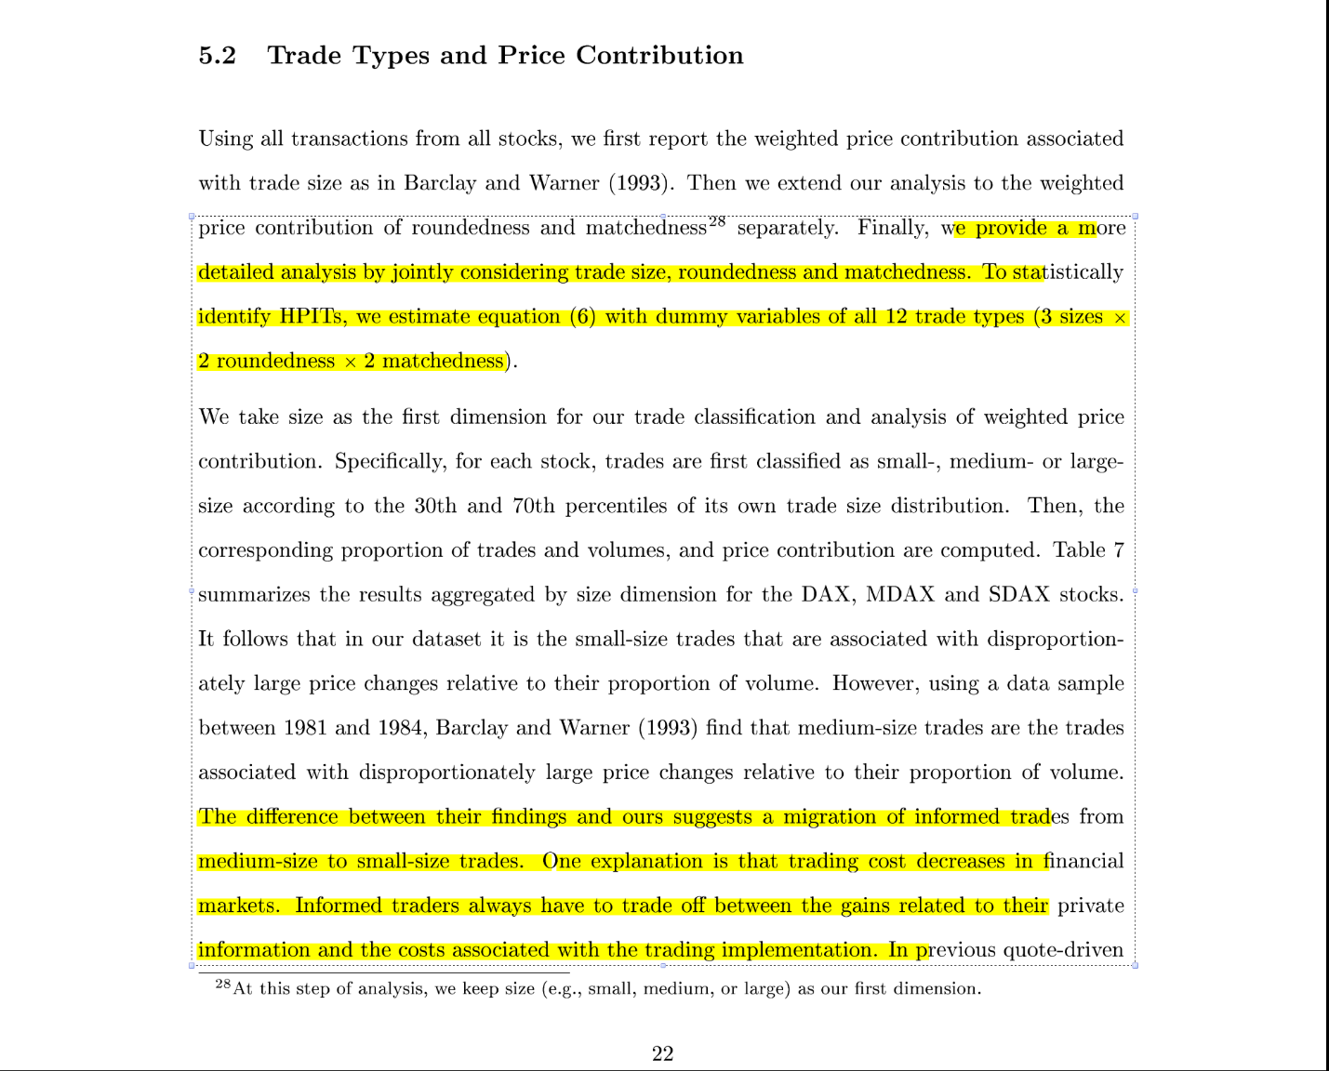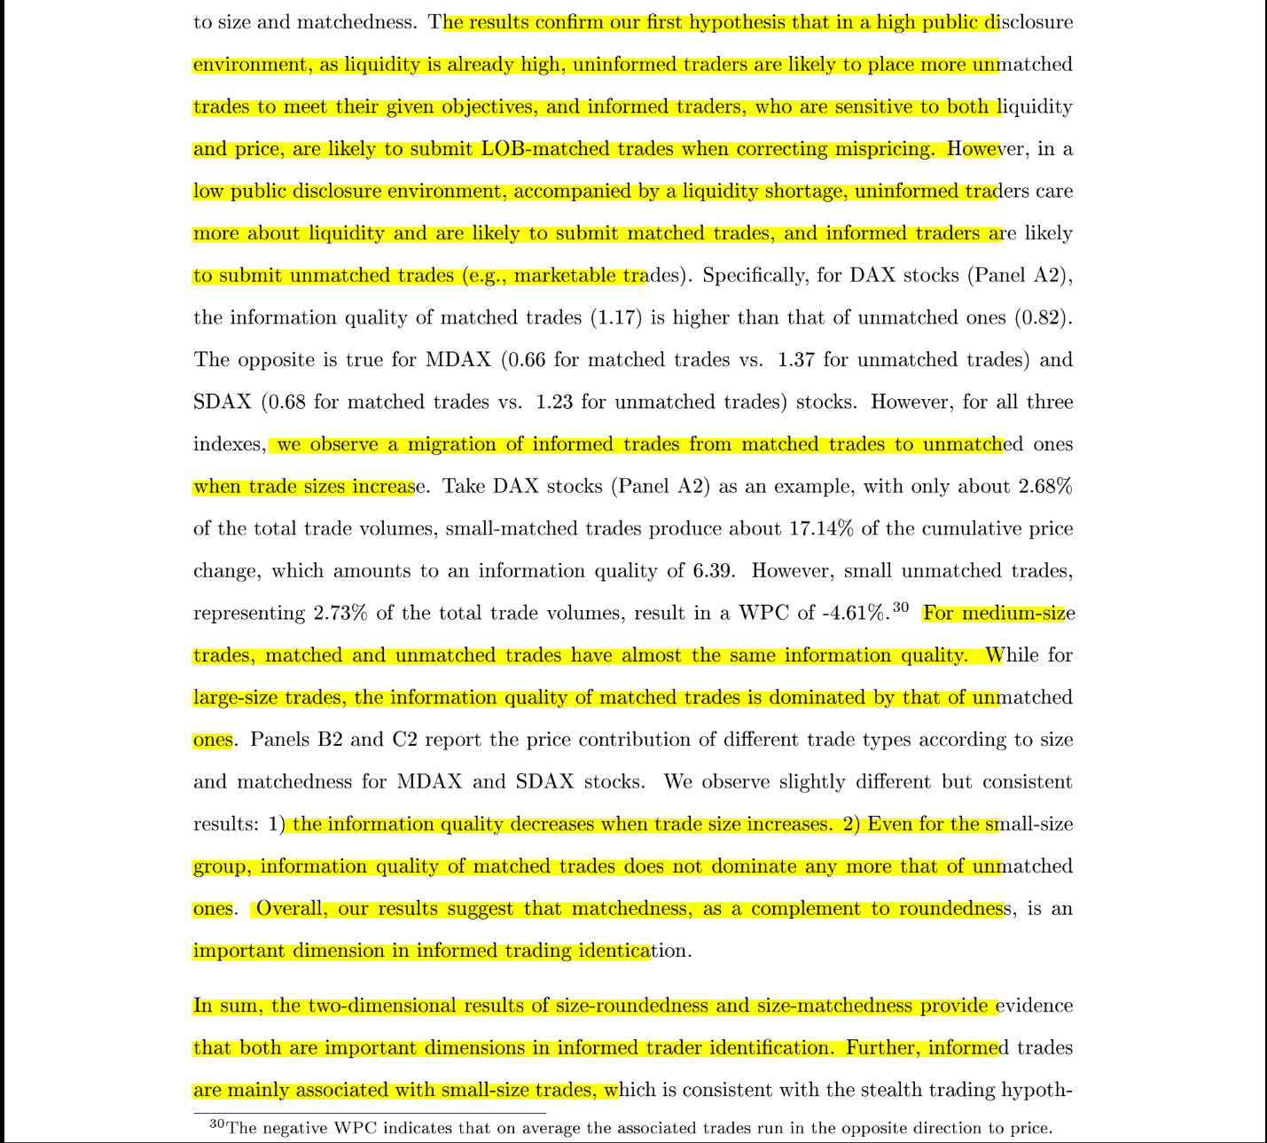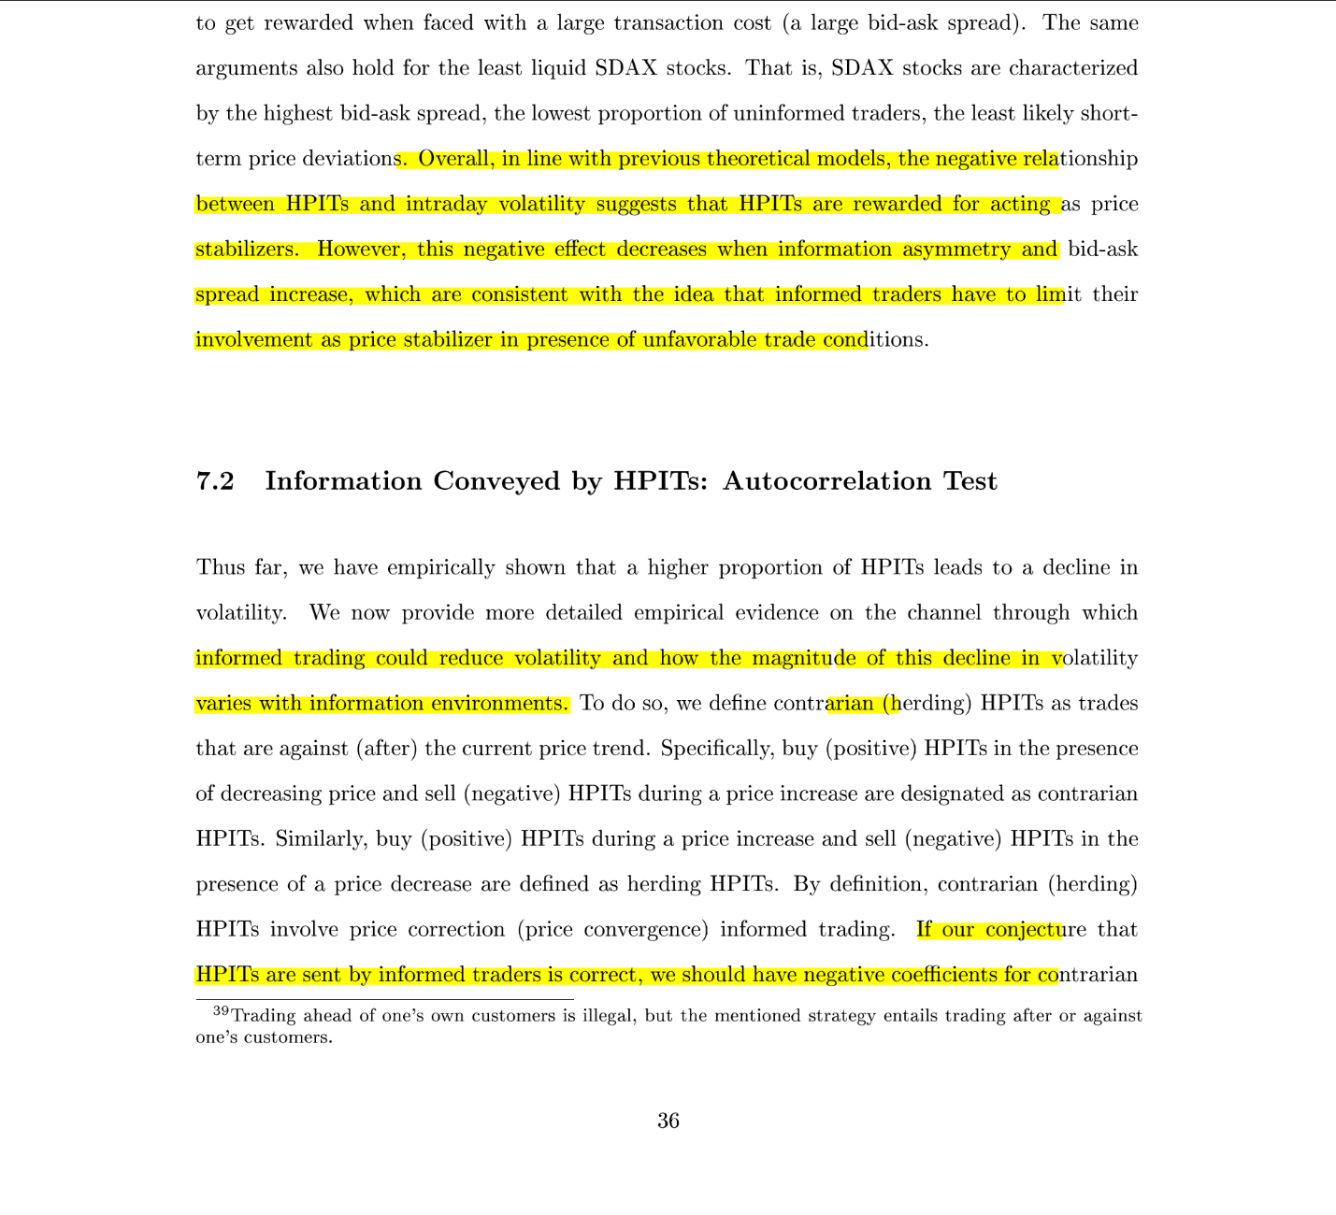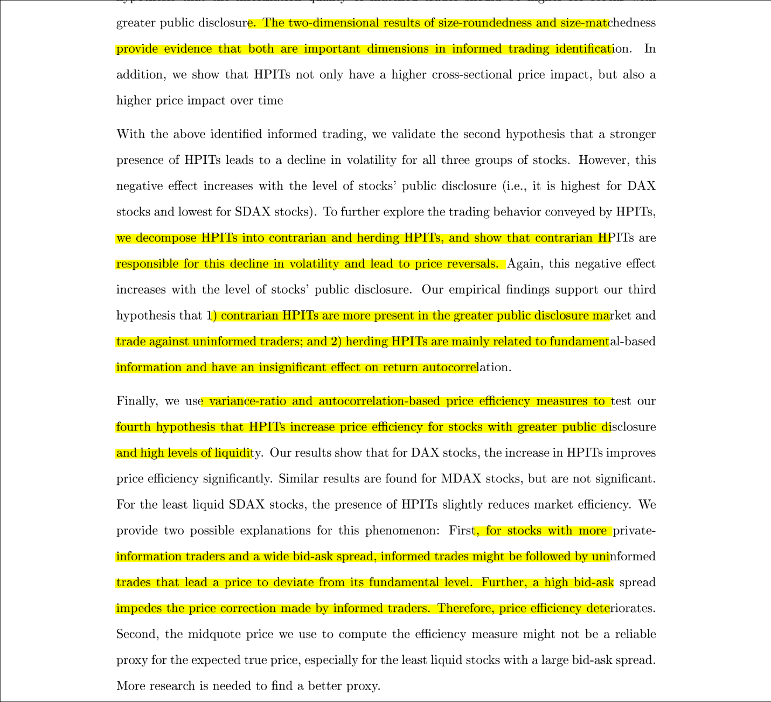

### Tracking Retail Investor Activity

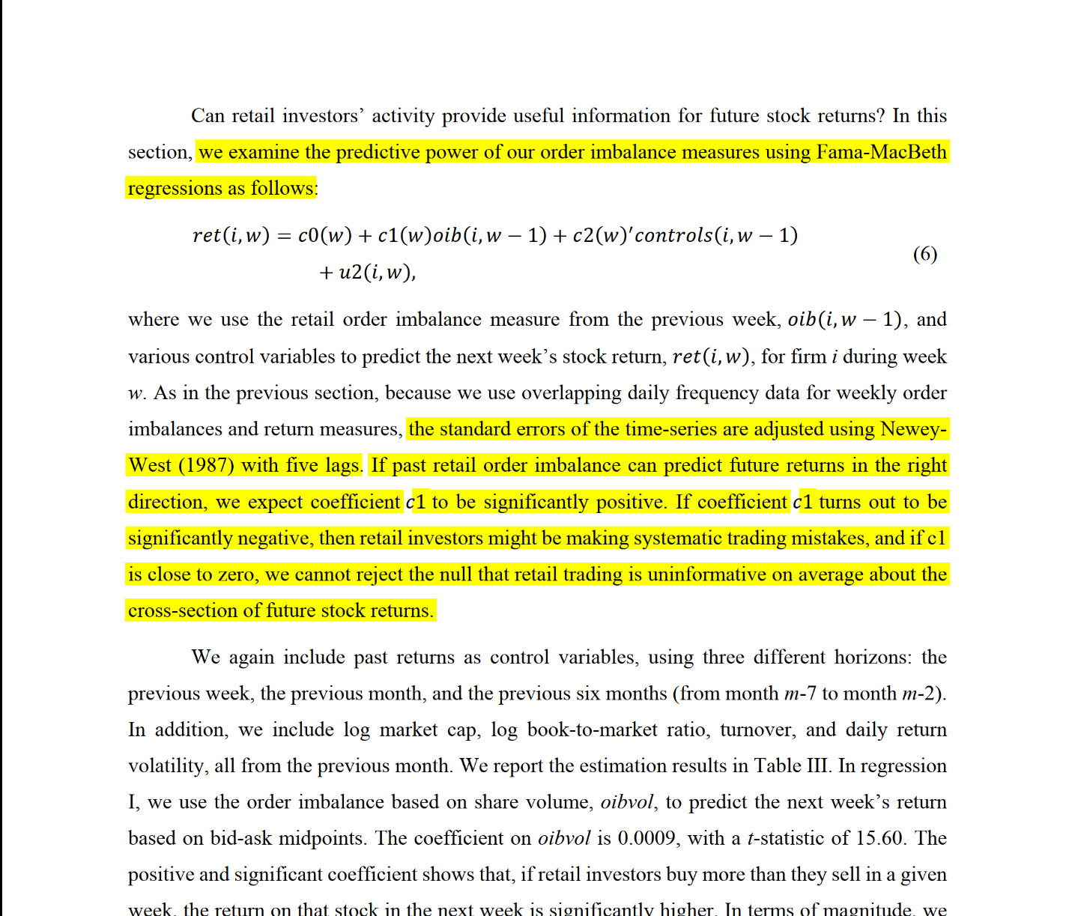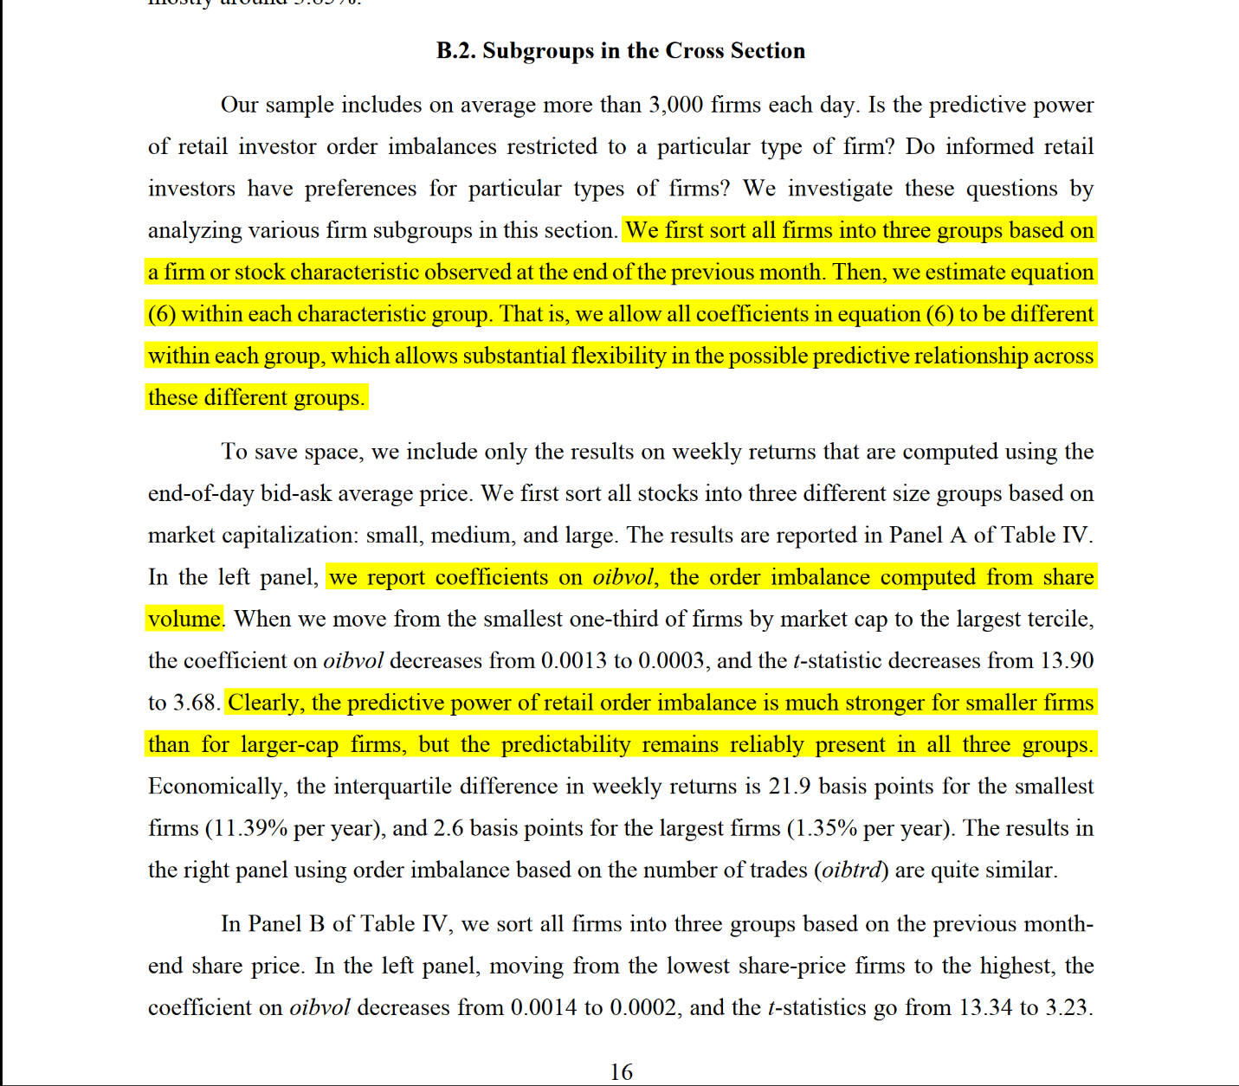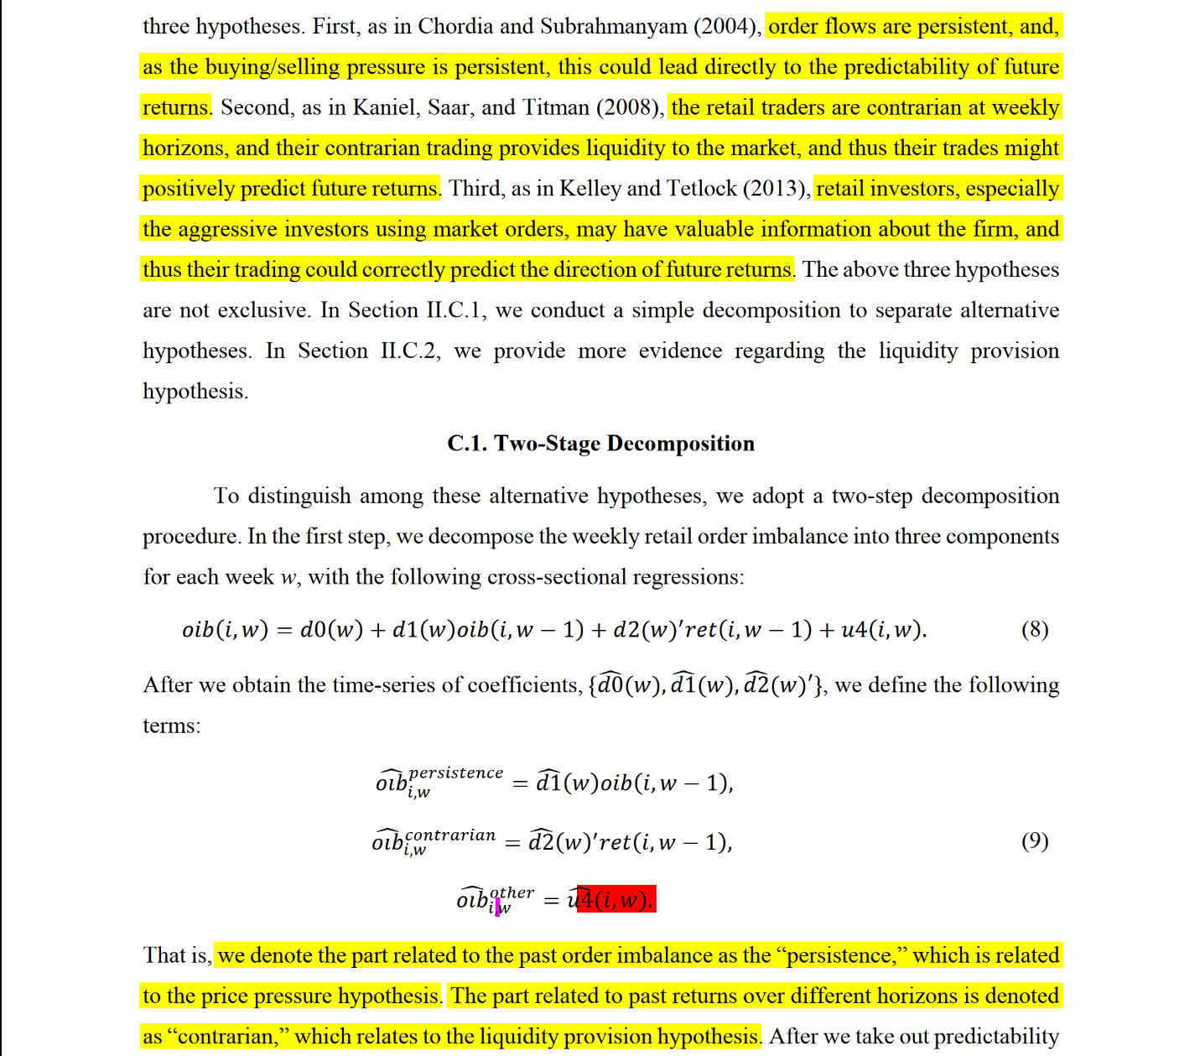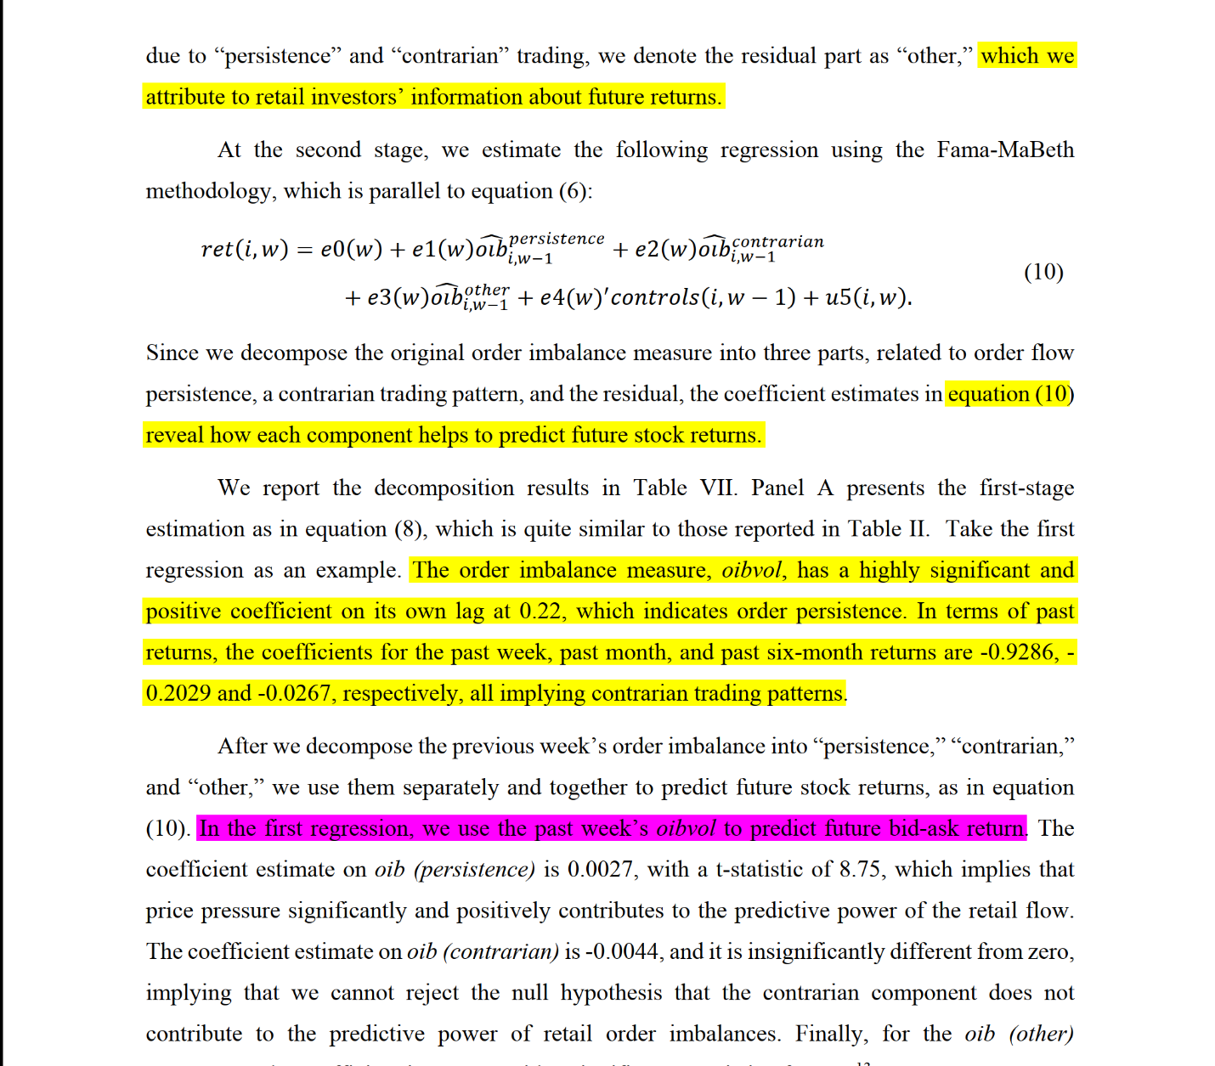

### Discerning Information from Trade Data

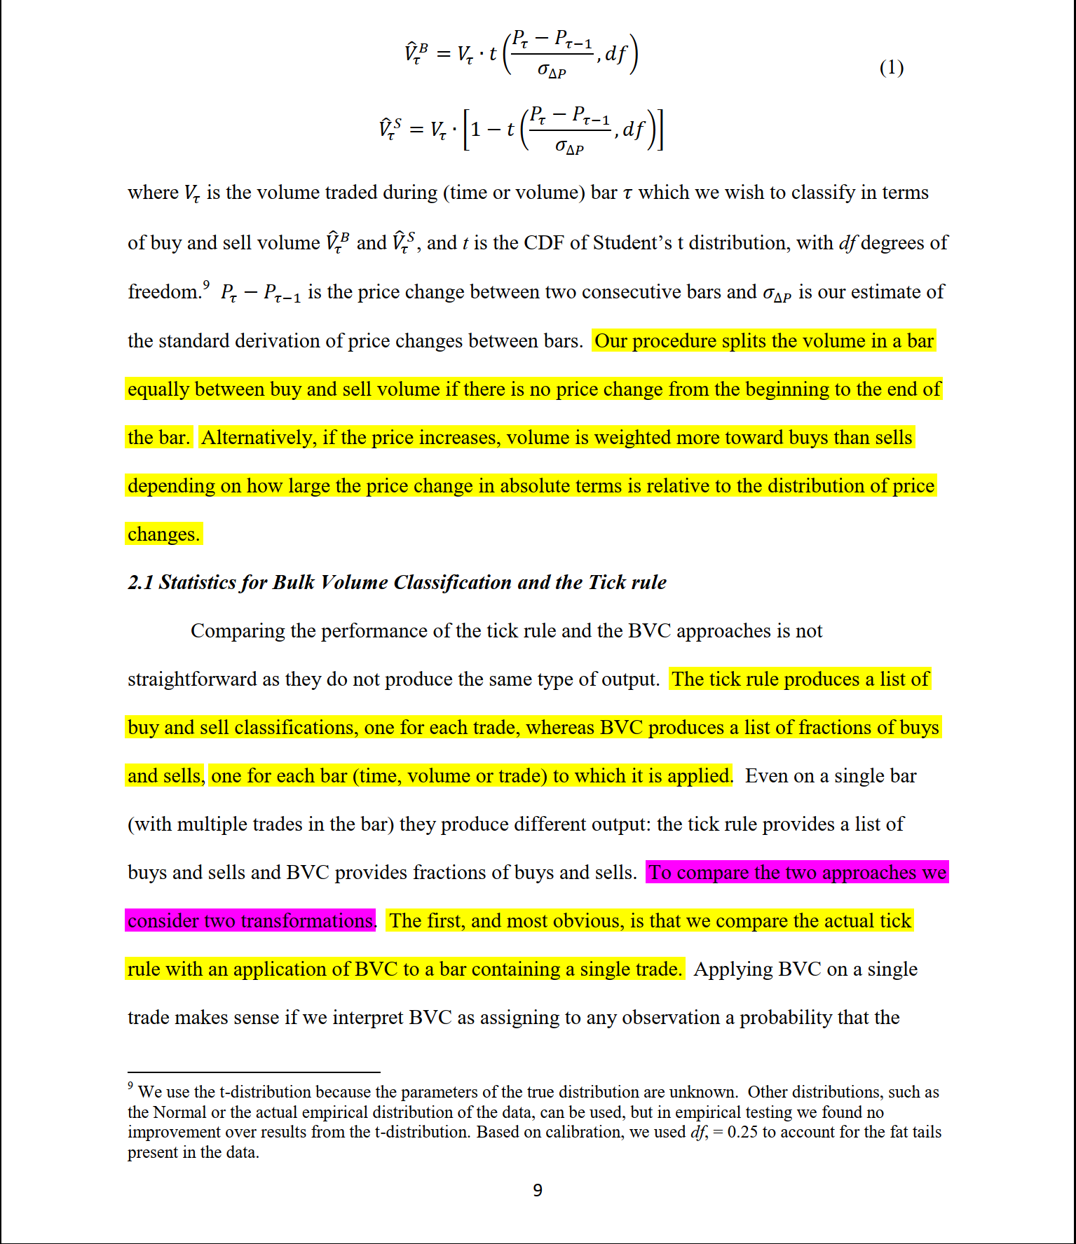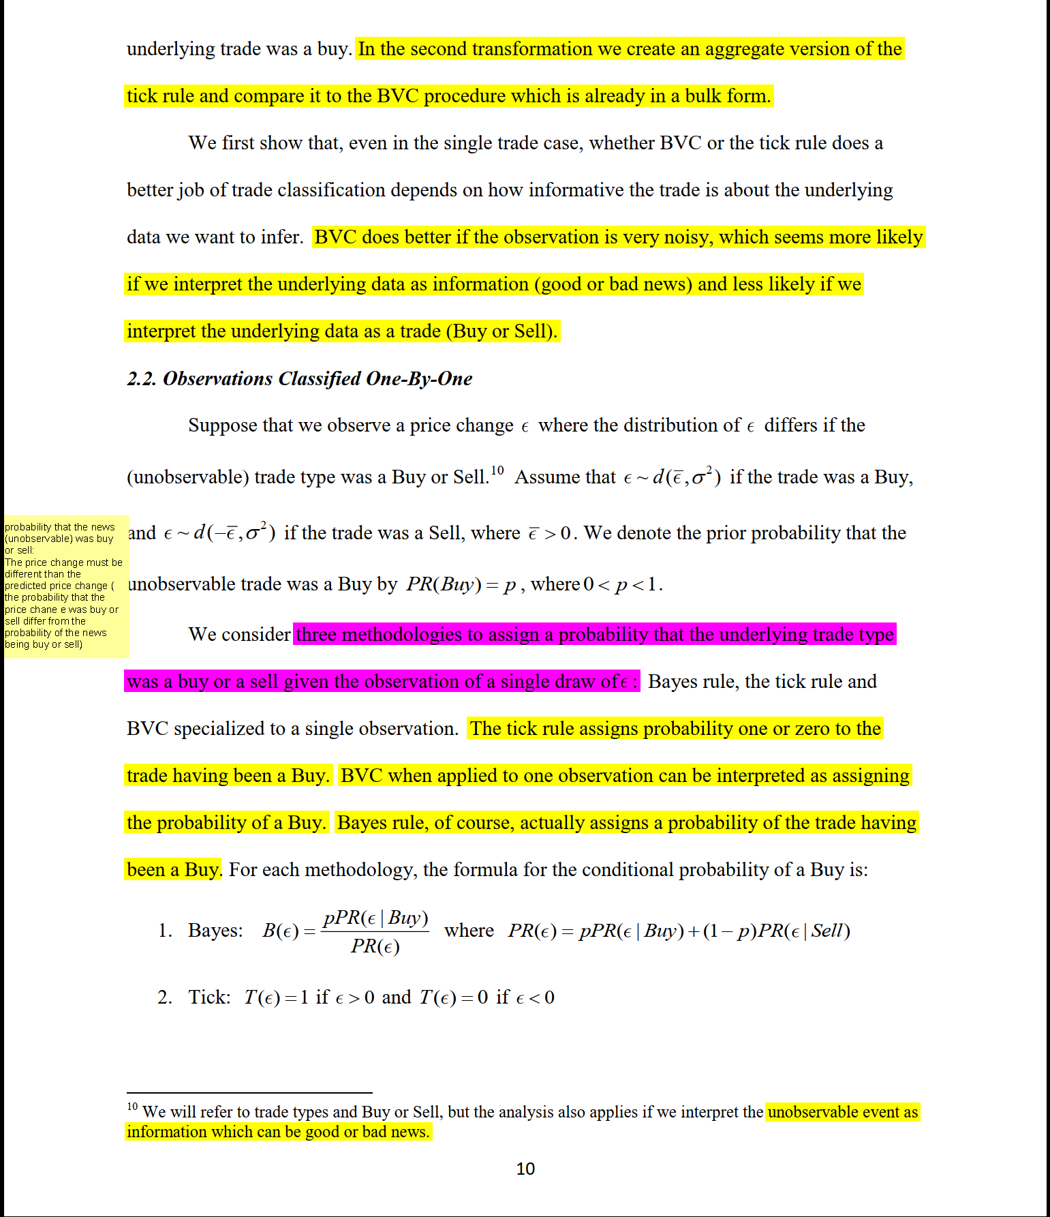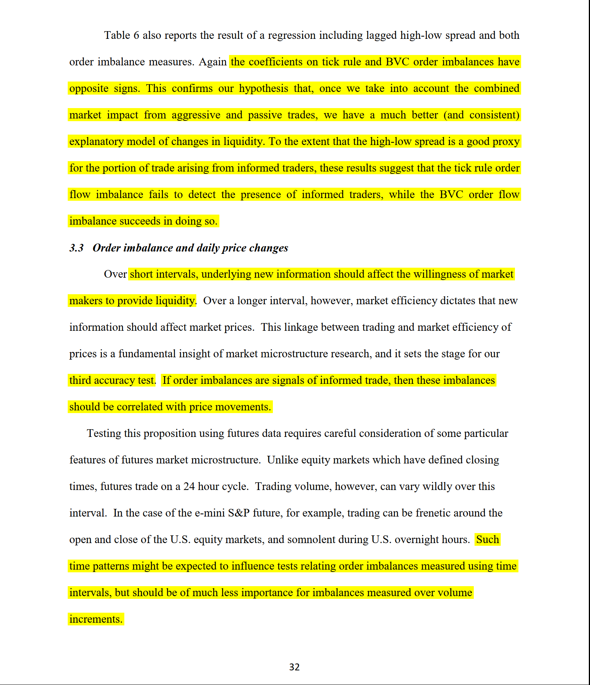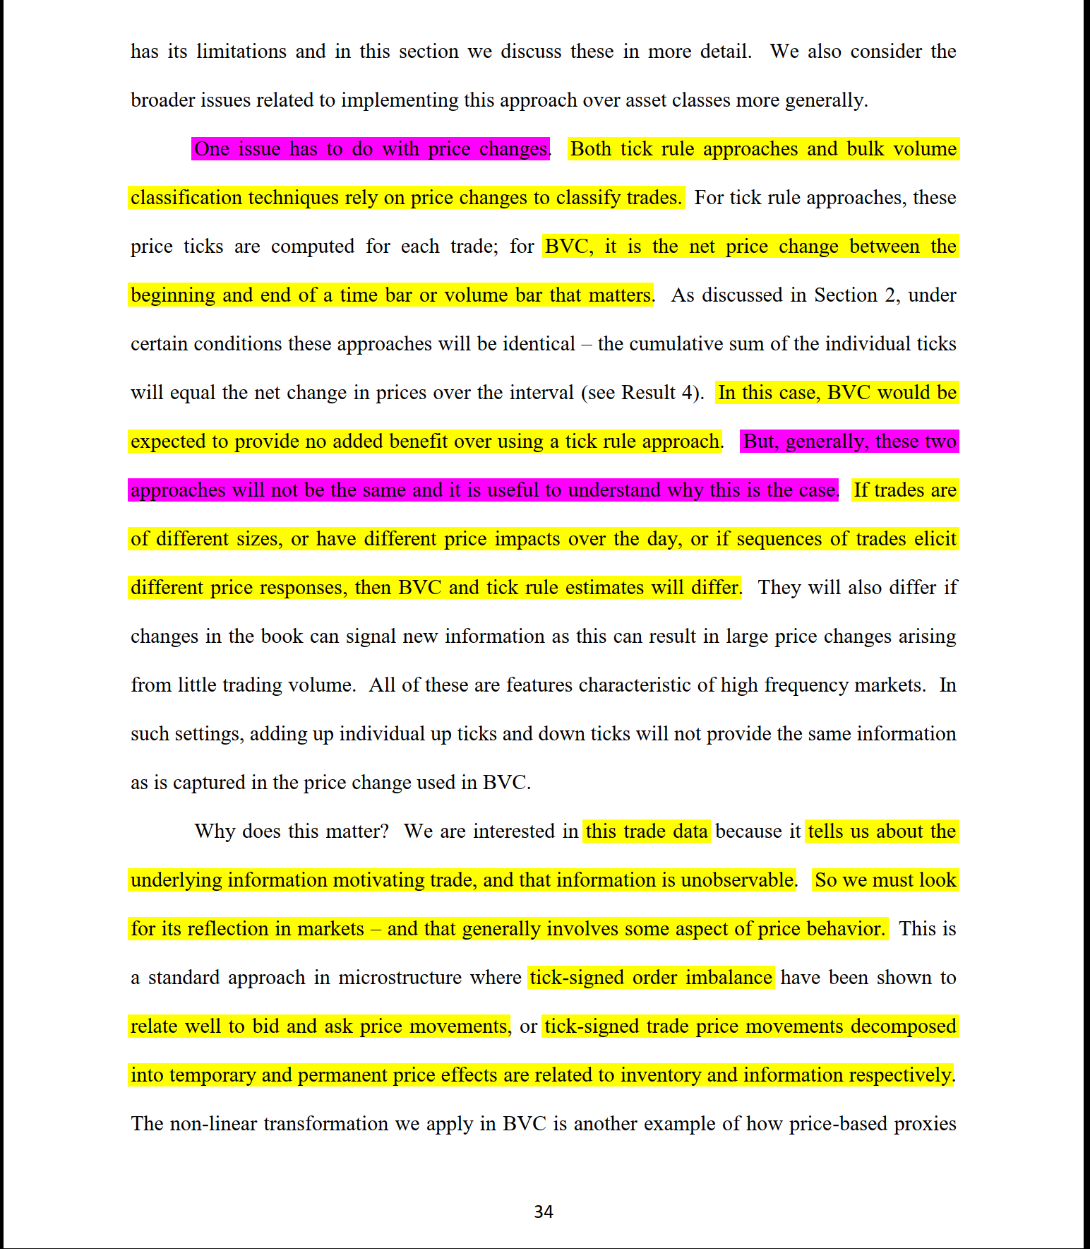

## Section 2

### Stock Market Forecasting Based on Text Mining Technology: A Support Vector Machine Method

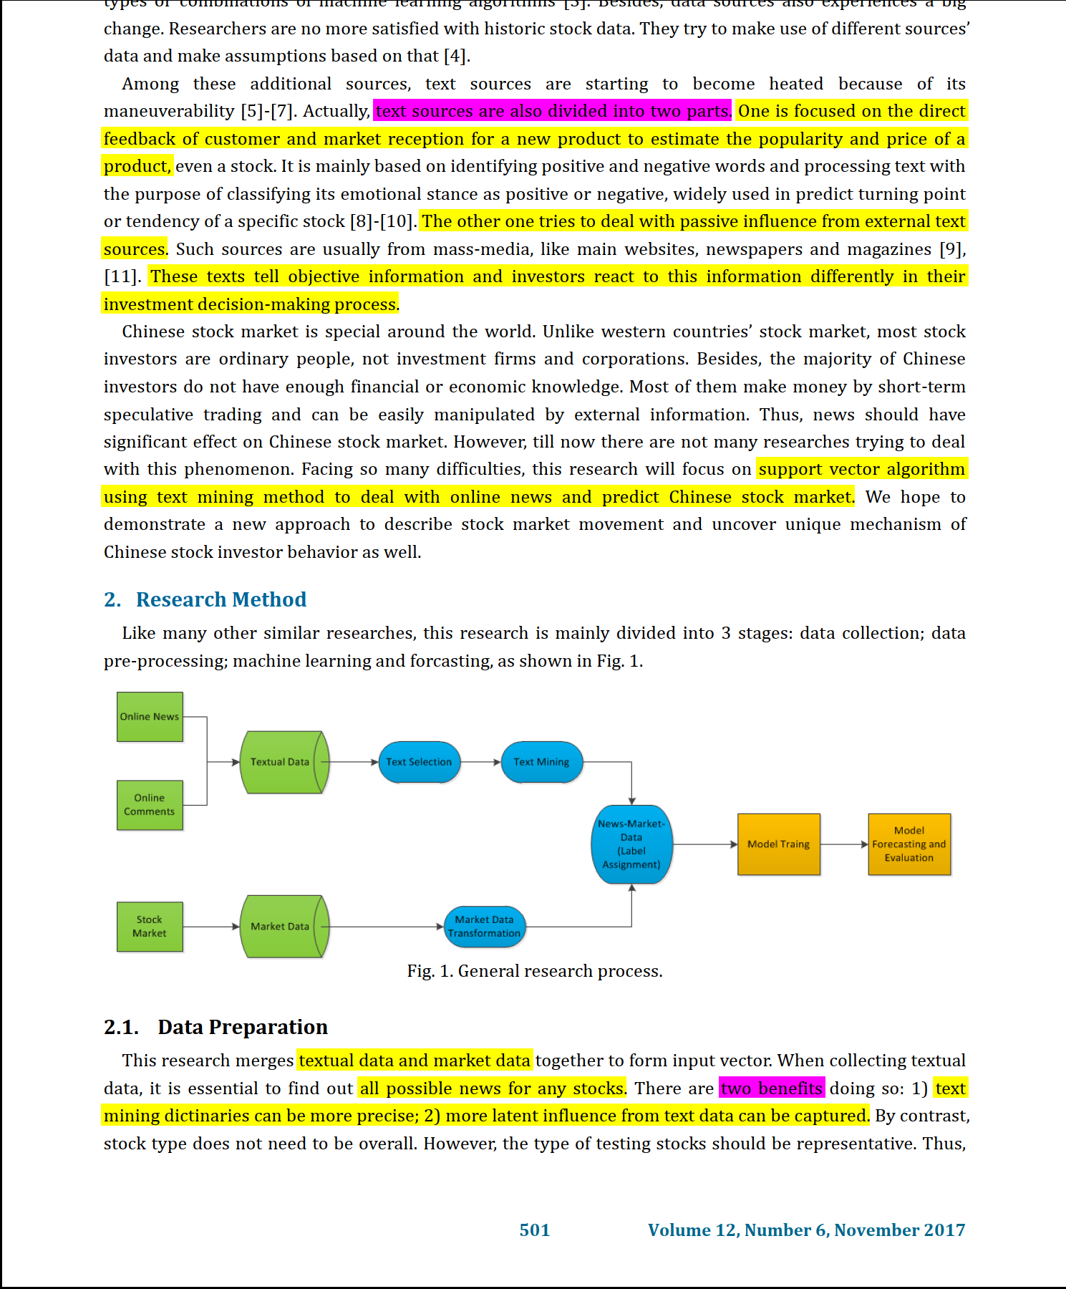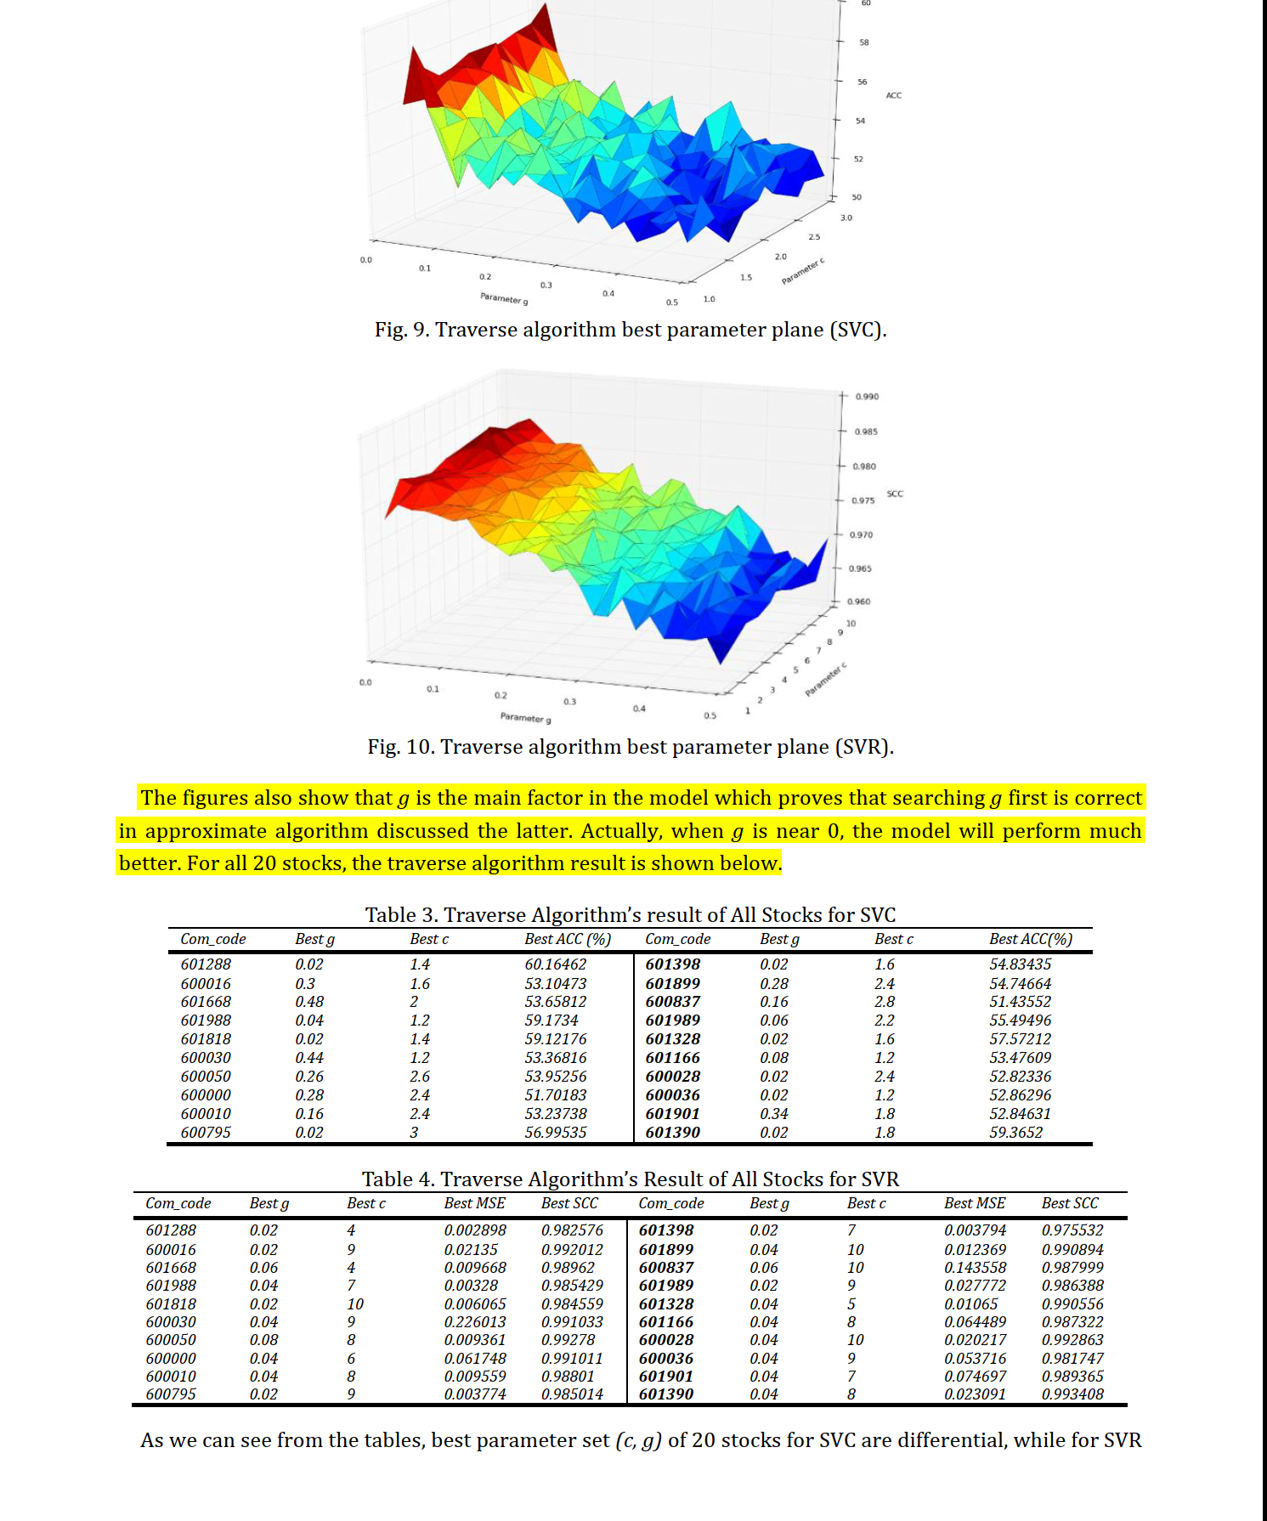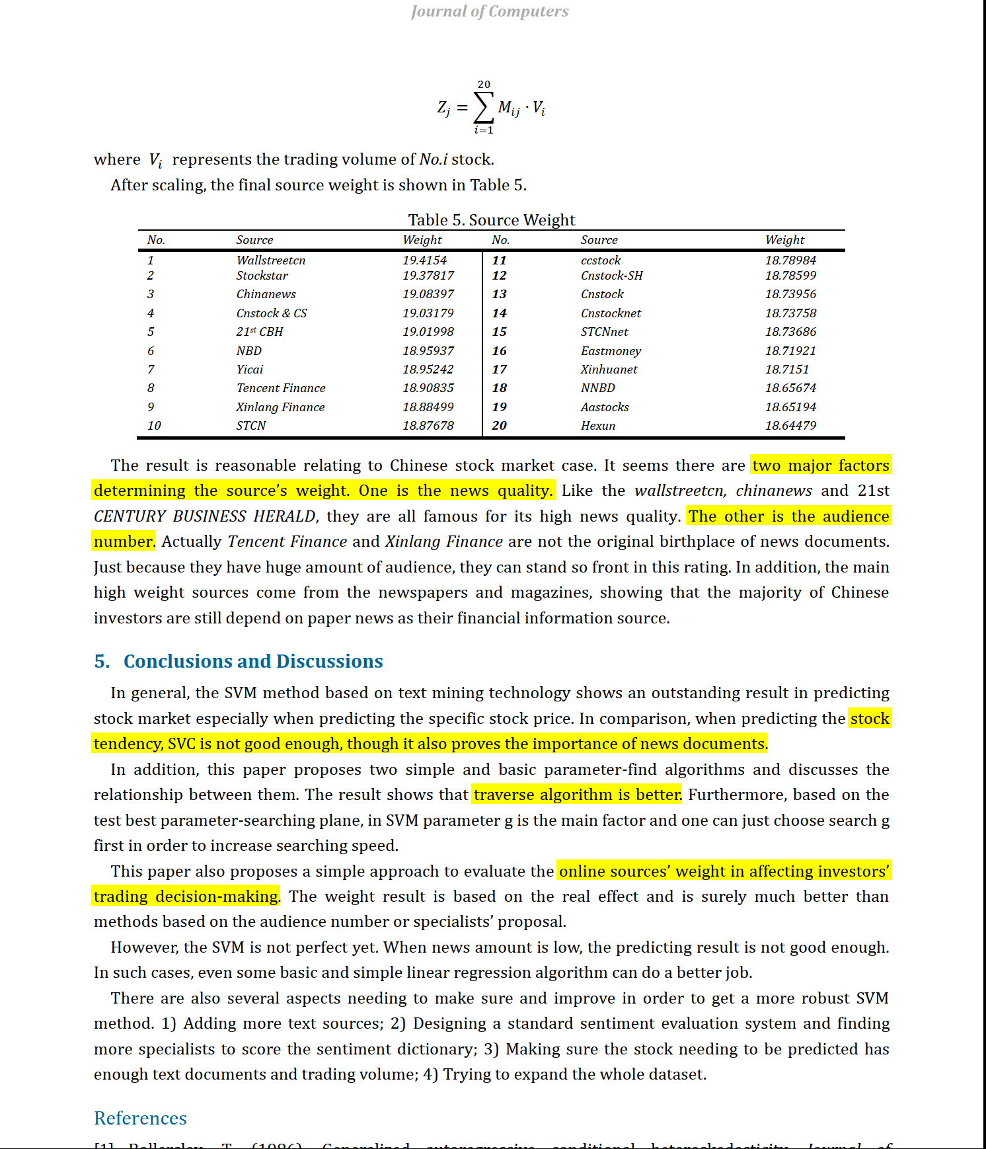

## Predicting Market Reactions to Bad News

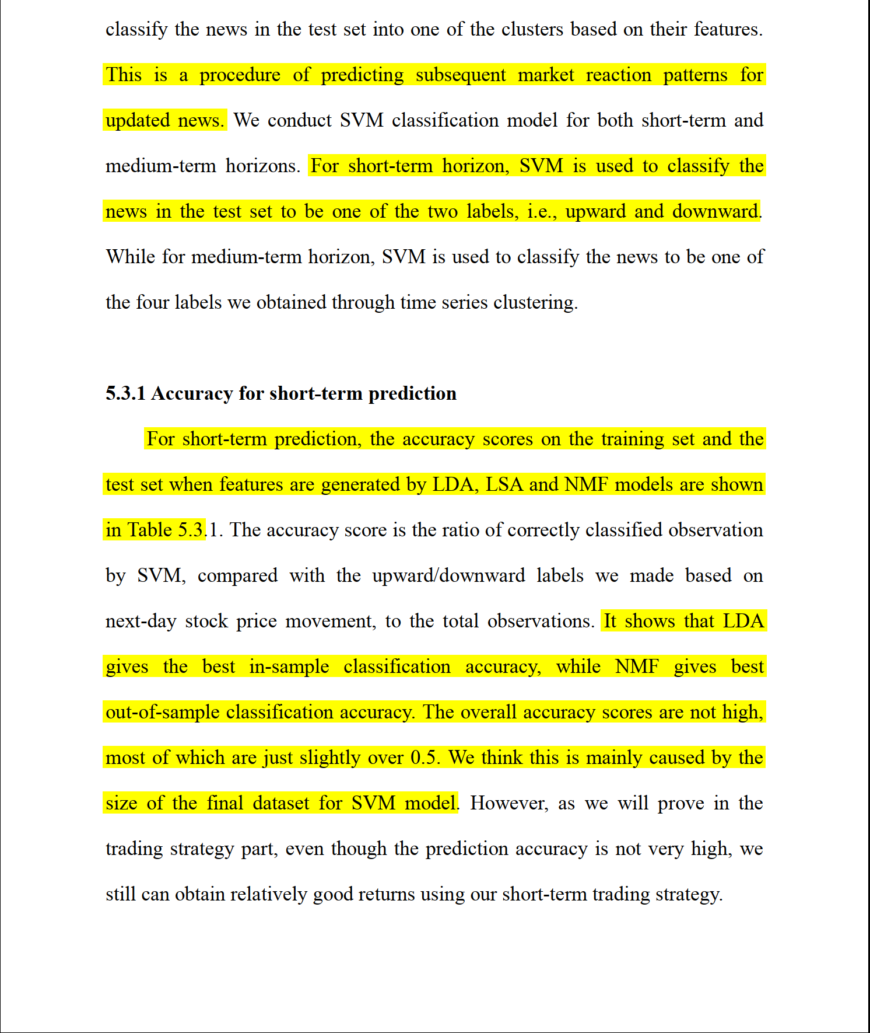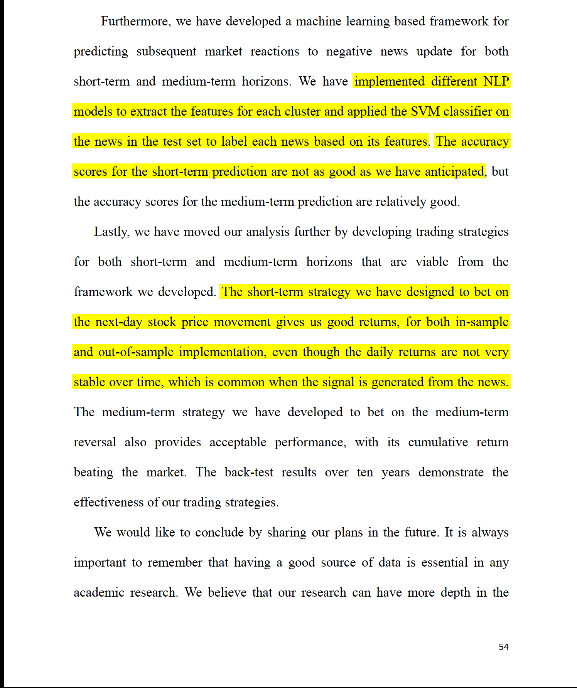

### The Democratization of Investment Research and the Informativeness of Retail Investor Trading

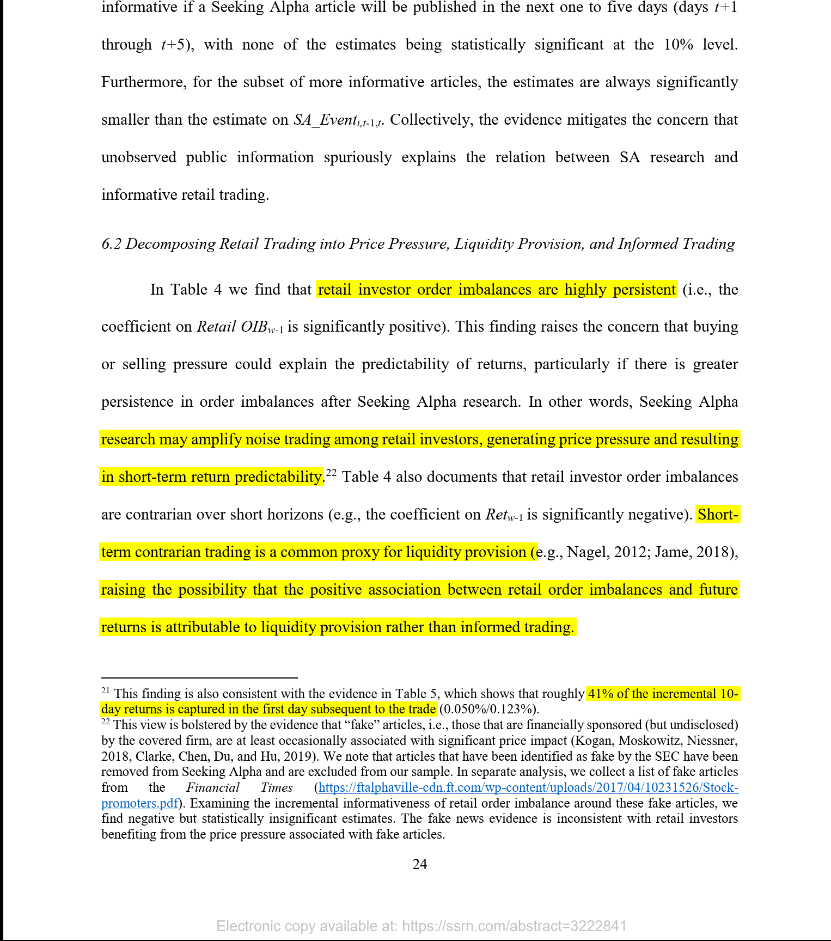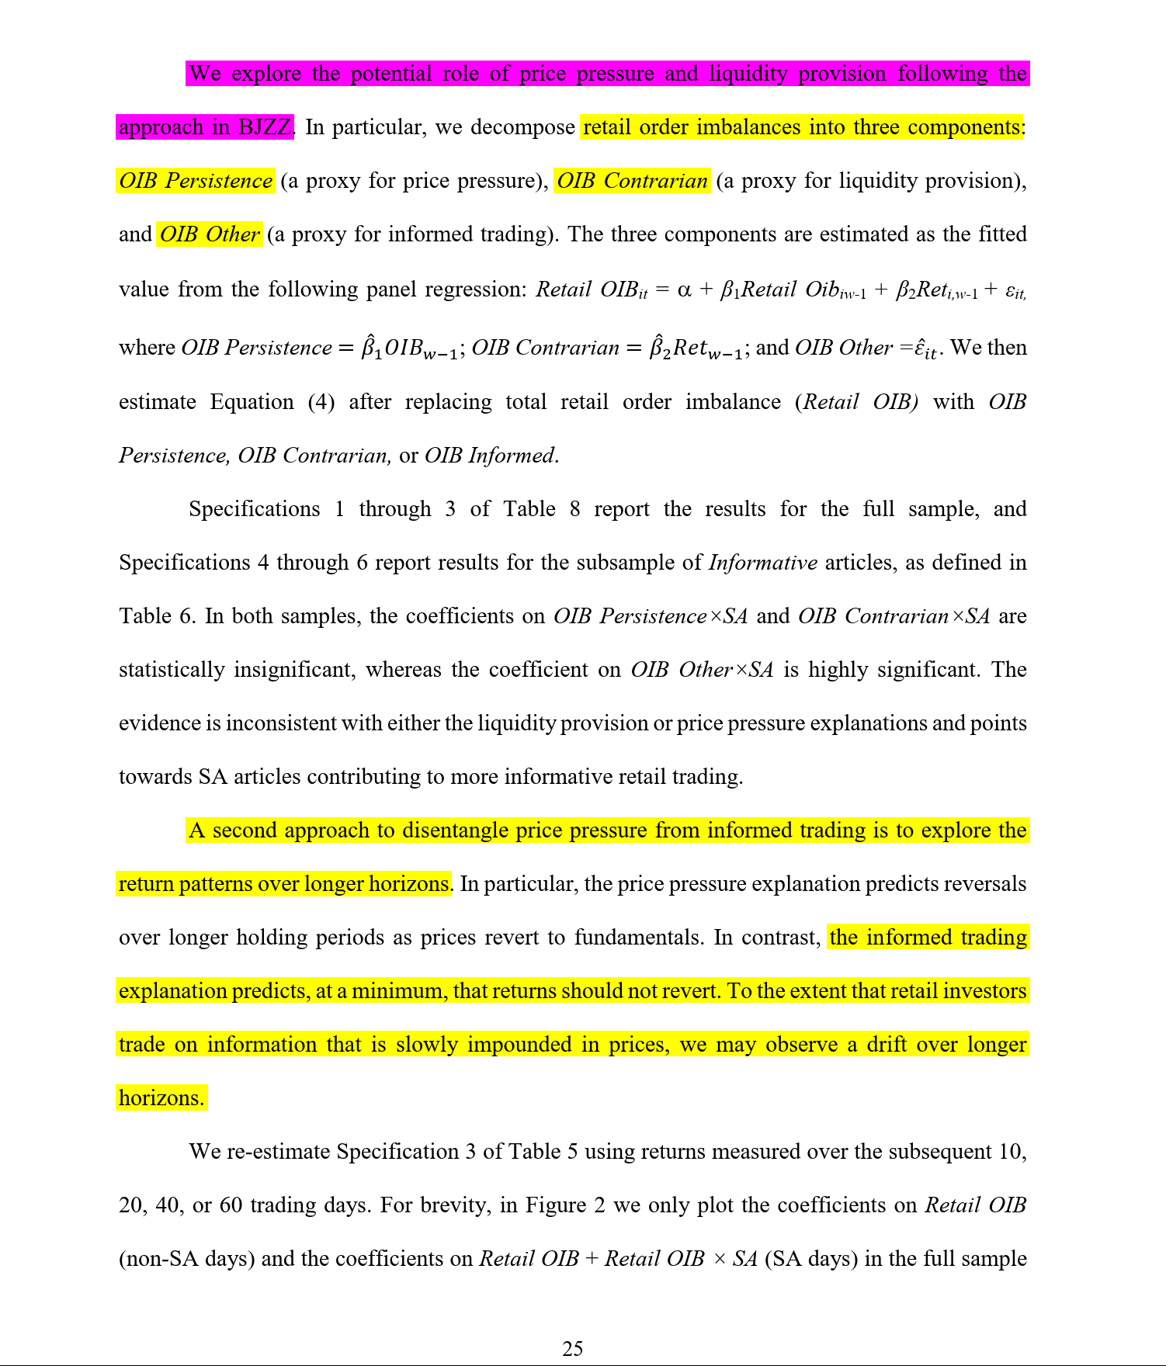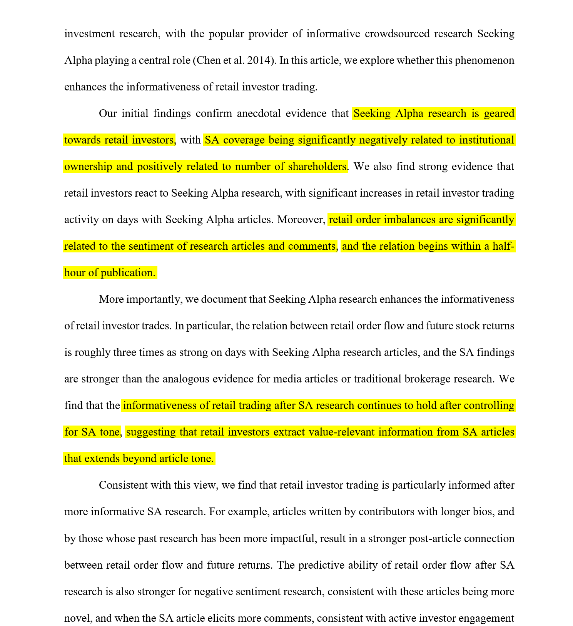

### Kinetic Component Analysis

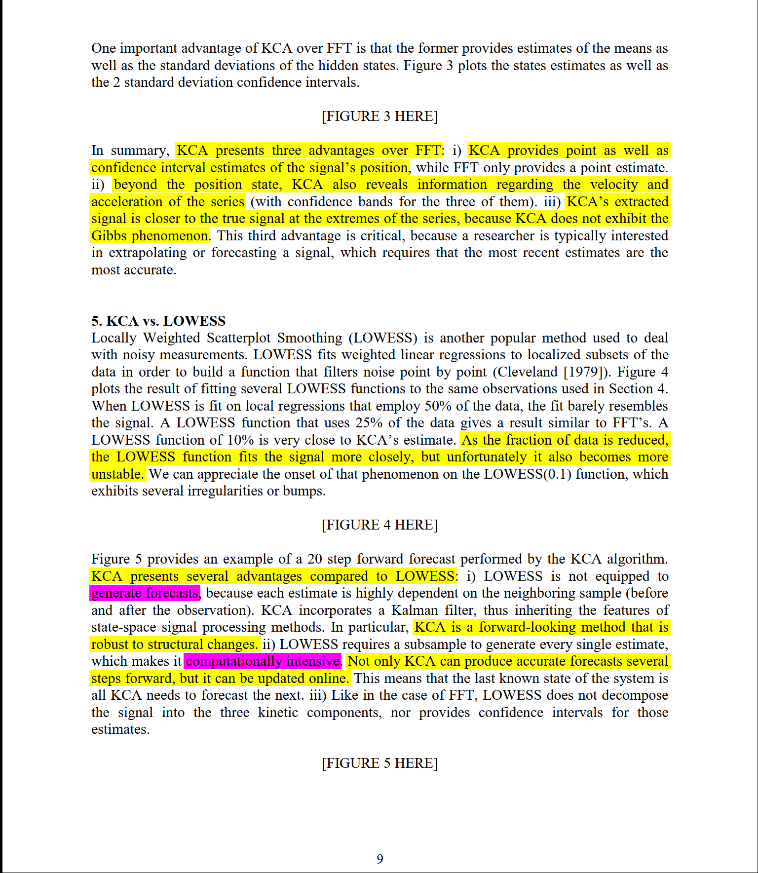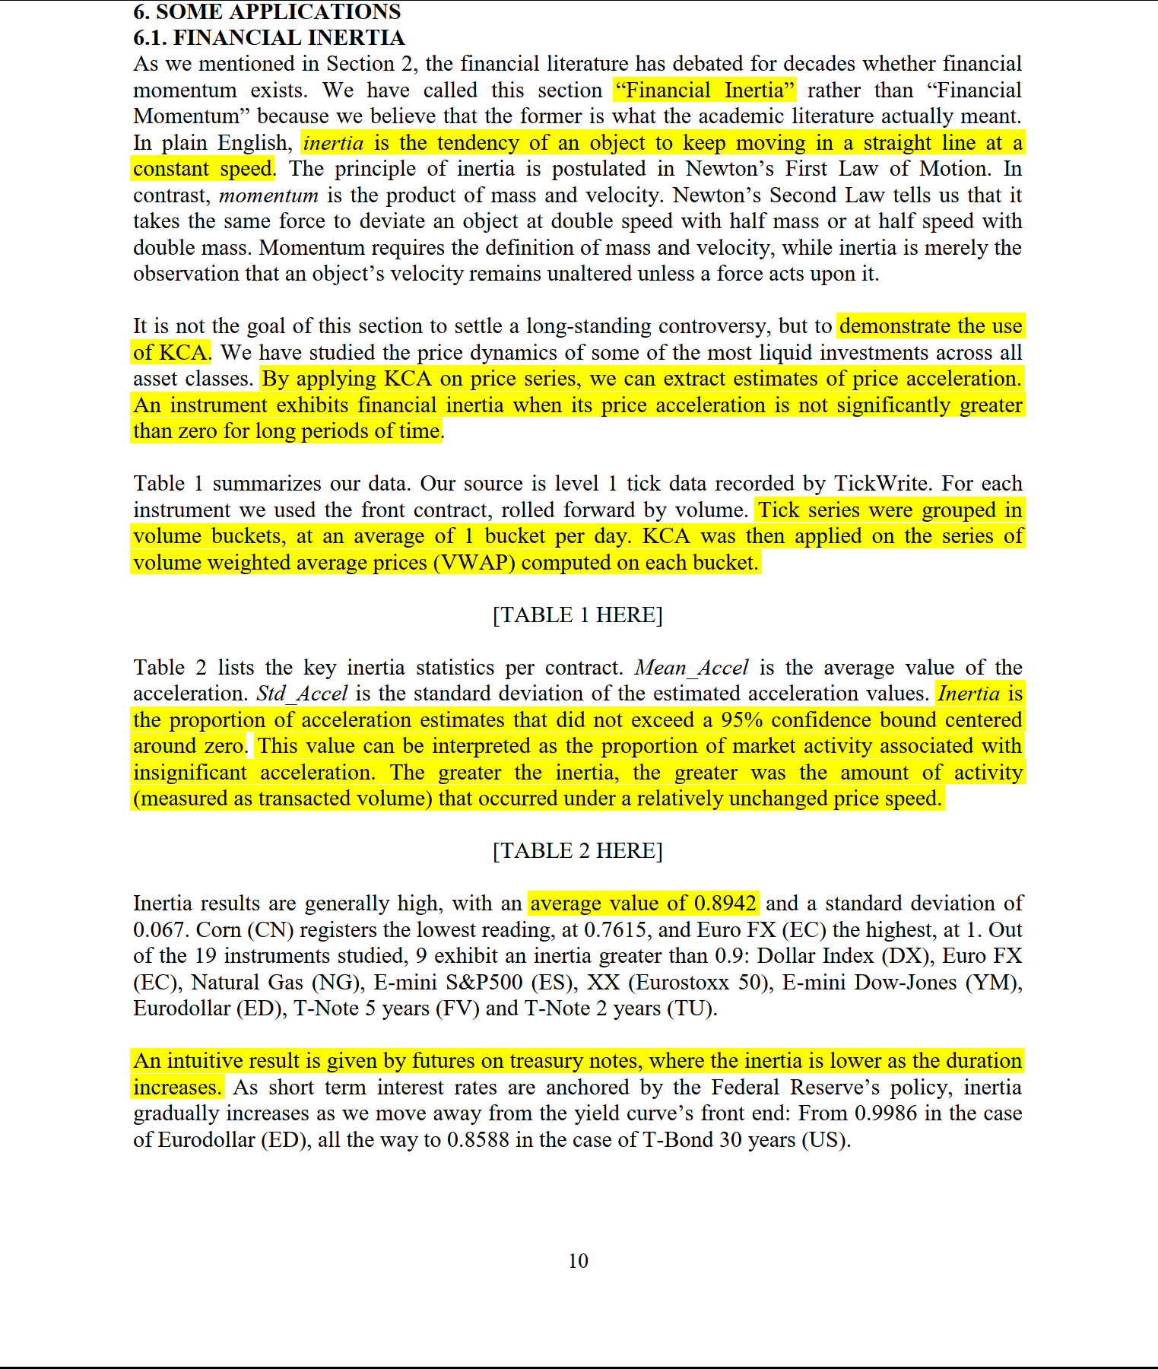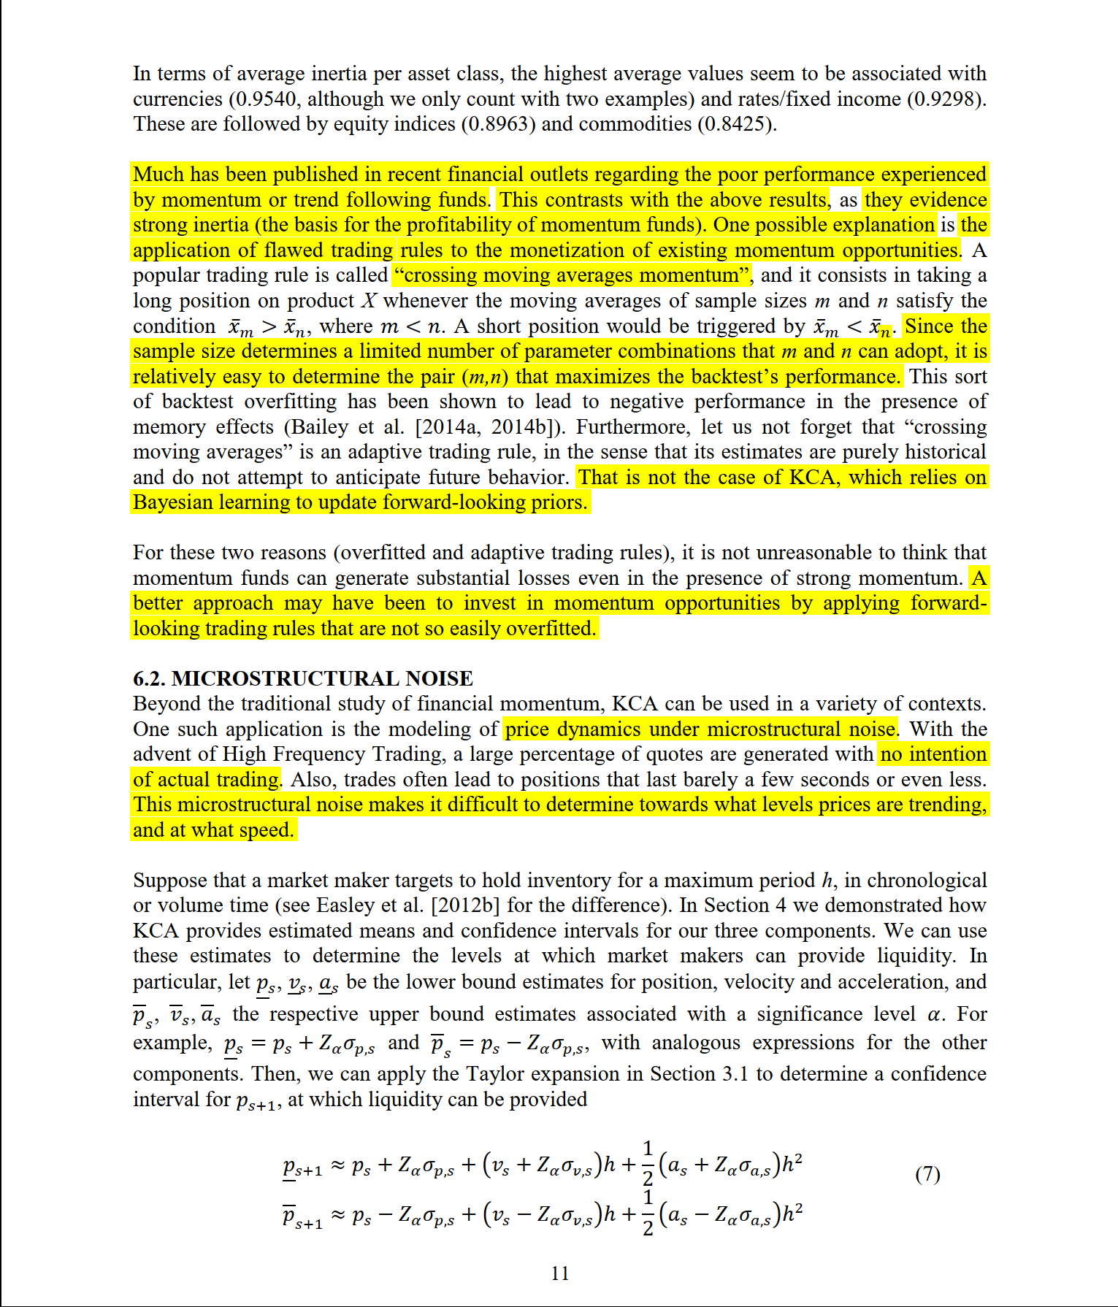

## Section 3

### Clustering Financial Return Distributions Using the Fisher Information Metric

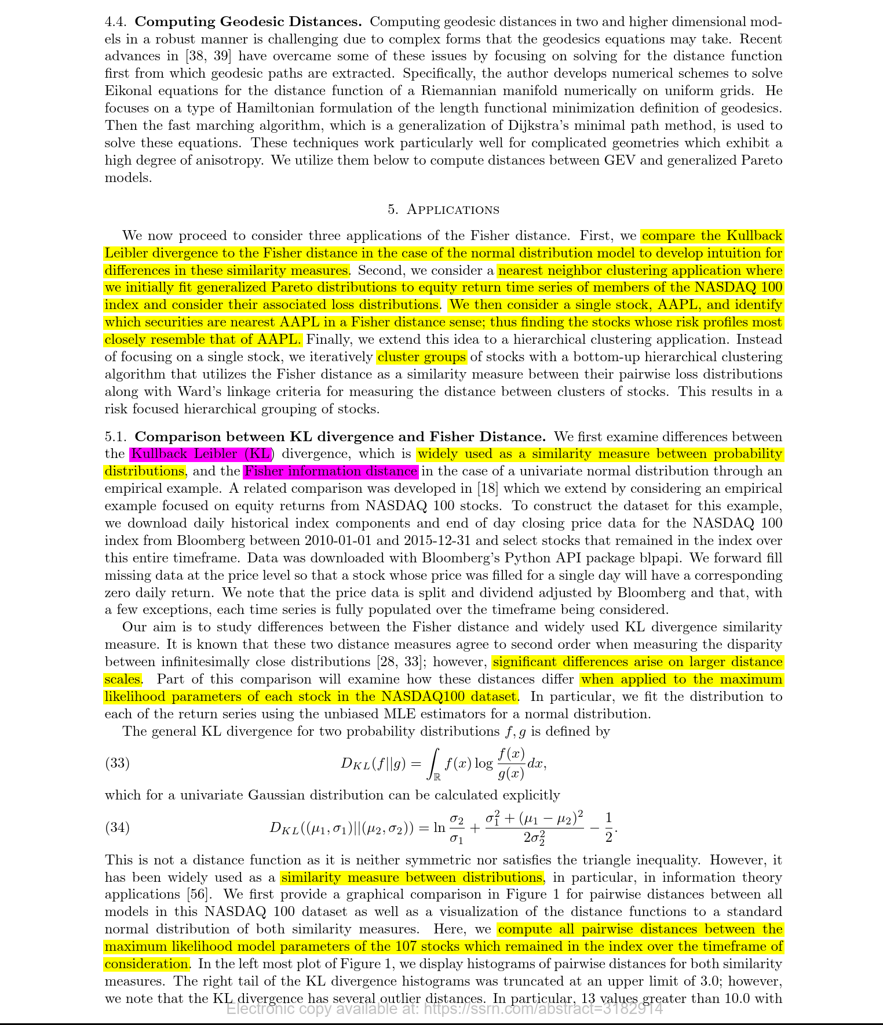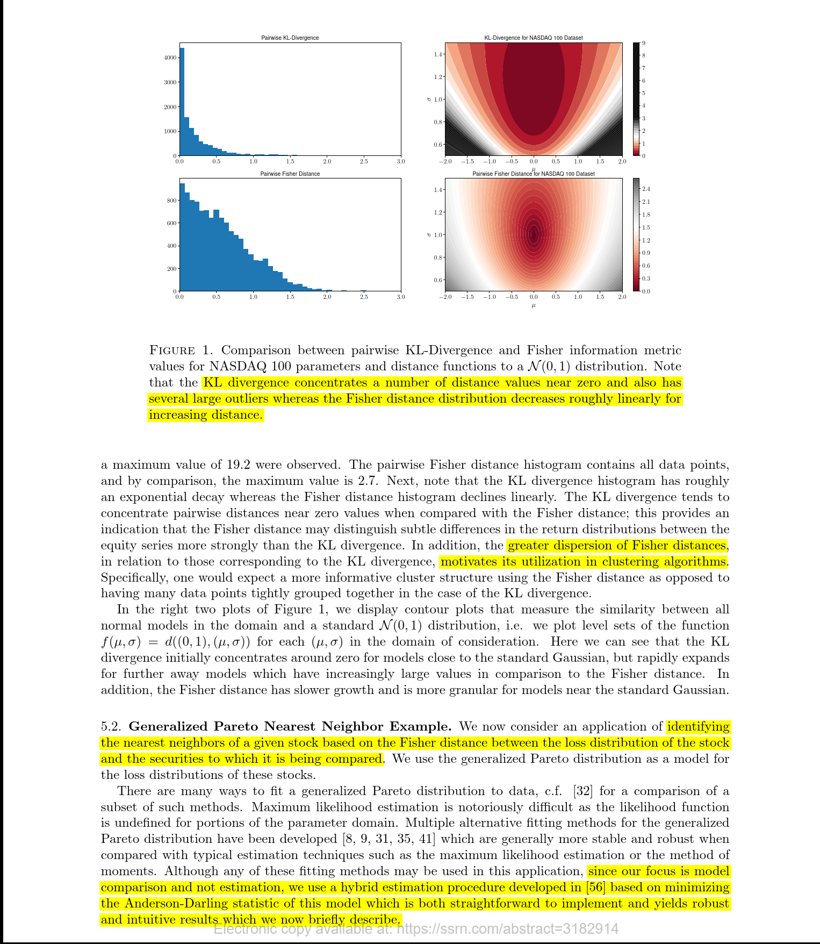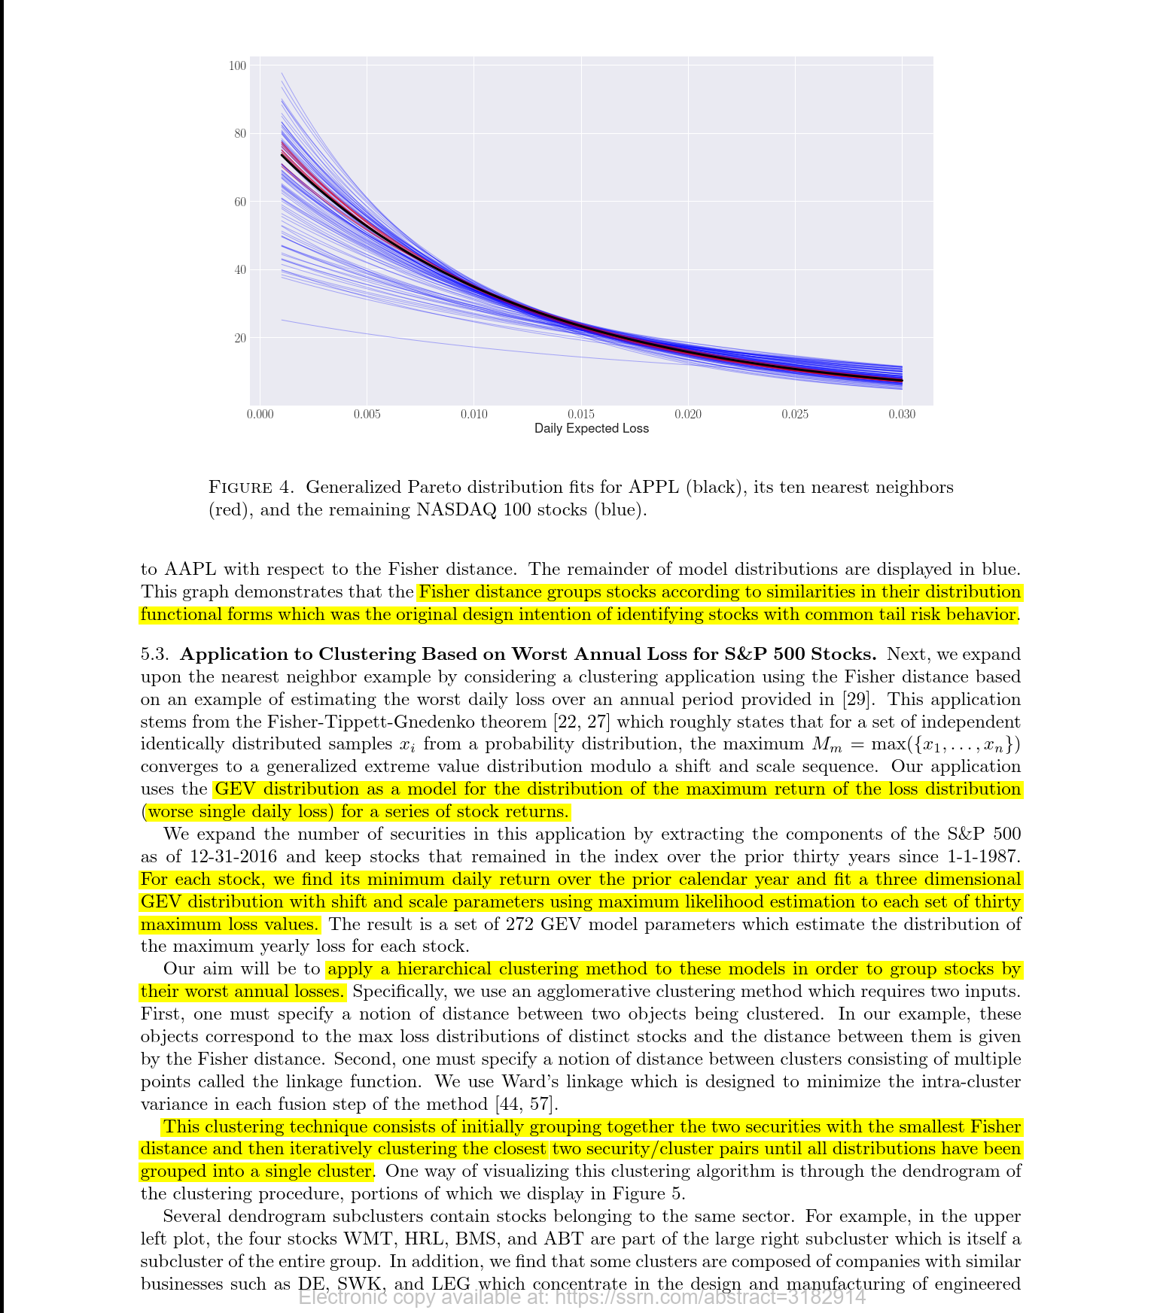

### Partial Mutual Information Analysis of Financial Networks

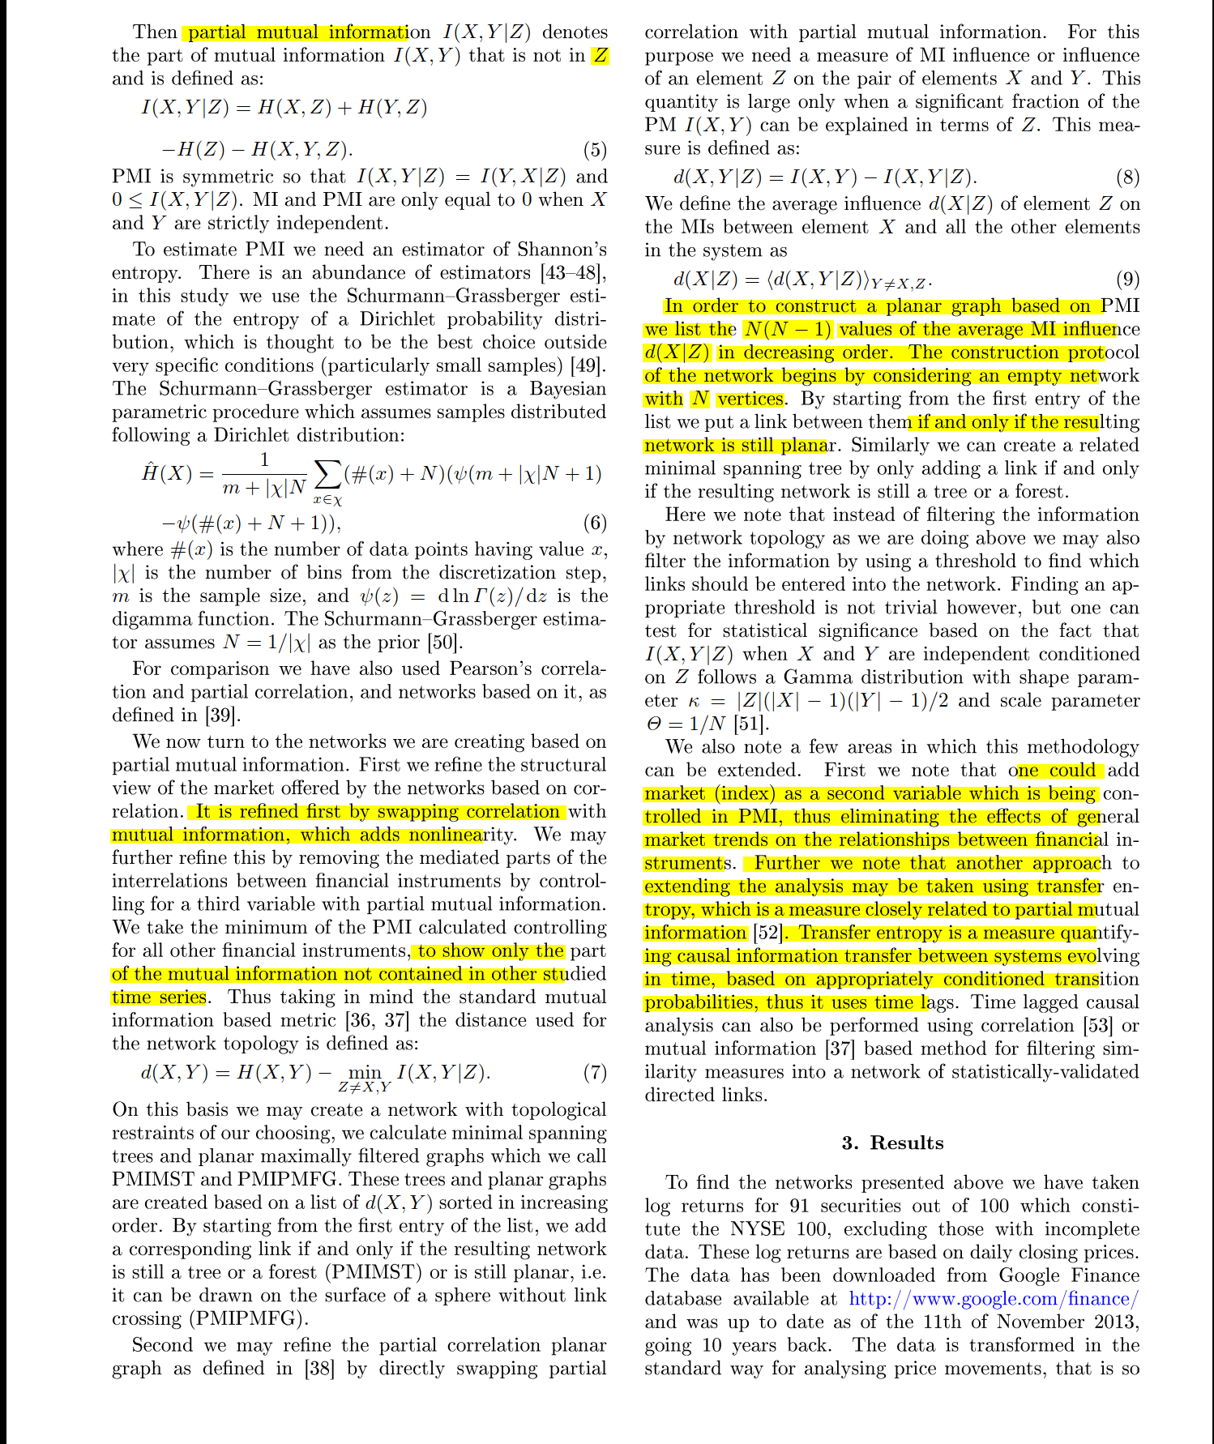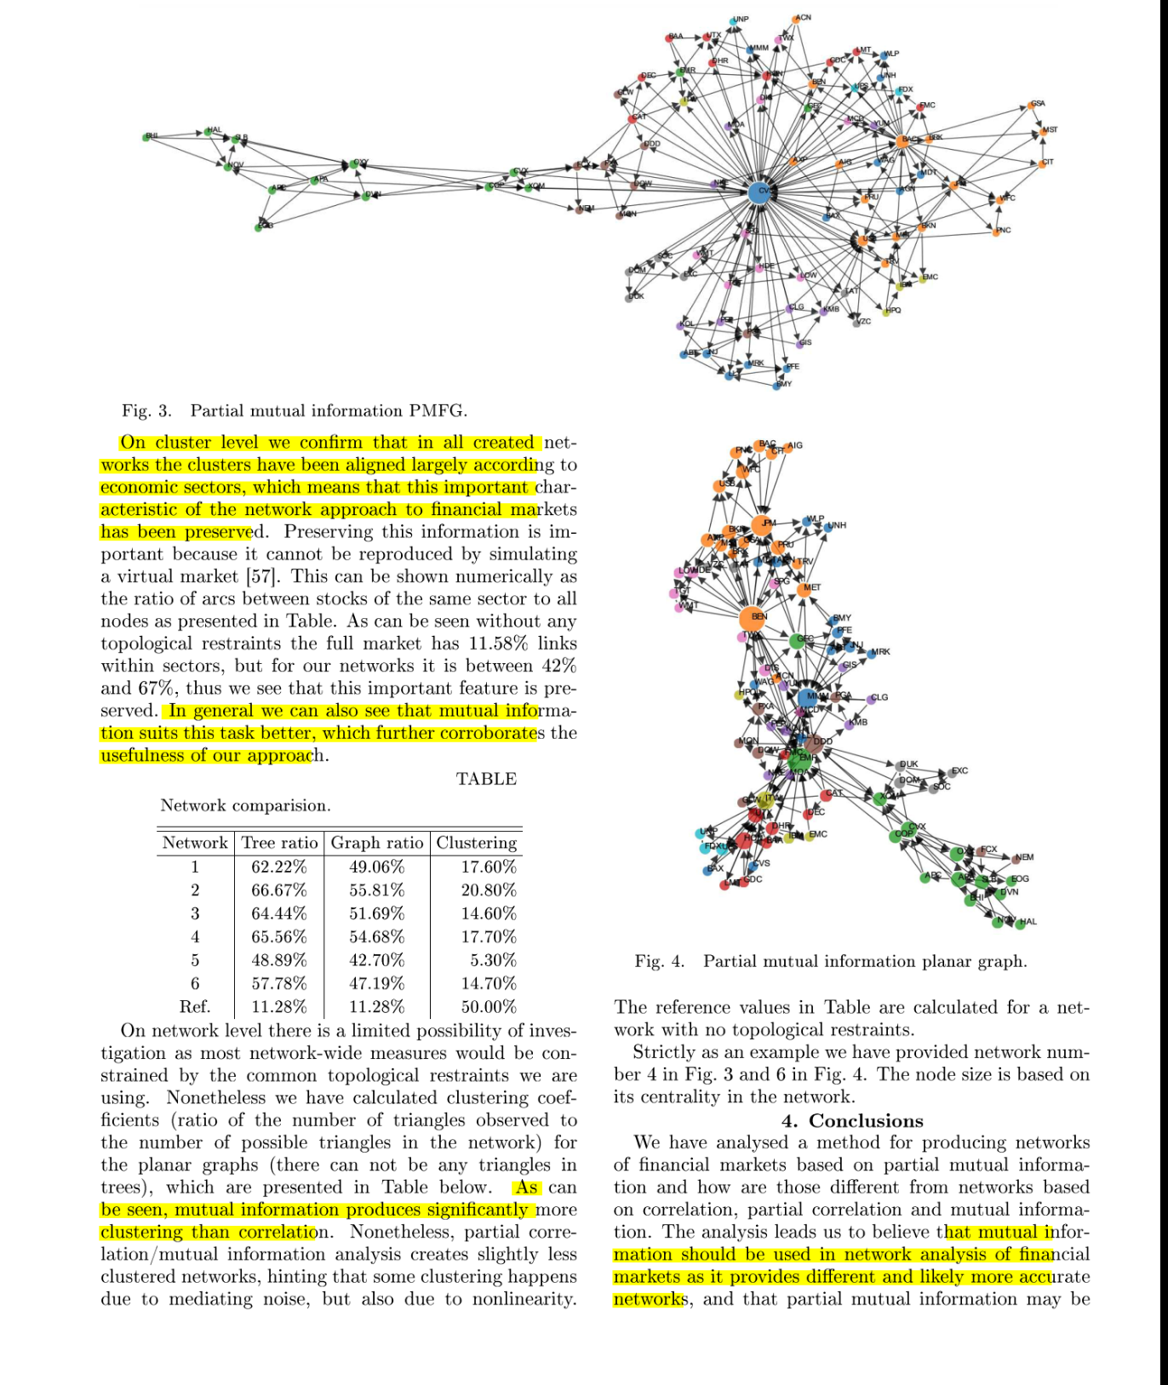

### Causal Non-Linear Financial Networks

